

Department of Computer Science

Lab Manual of
SPEECH PROCESSING AND RECOGNITION MAI574
Class Name: V MScAIML
Master of Science Artifitial Intelligence and Machine Learning
2025-26
Prepared by: Abhijith E Verified by: Dr.Helen K Joy

Department Overview
Department of Computer Science of CHRIST (Deemed to be University) strives to shape outstanding computer professionals with ethical and human values to reshape nation’s destiny. The training imparted aims to prepare young minds for the challenging opportunities in the IT industry with a global awareness rooted in the Indian soil, nourished and supported by experts in the field.

Vision
The Department of Computer Science endeavours to imbibe the vision of the
University “Excellence and Service”. The department is committed to this philosophy which pervades every aspect and functioning of the department.

Mission
“To develop IT professionals with ethical and human values”. To accomplish our mission, the department encourages students to apply their acquired knowledge and skills towards professional achievements in their career. The department also moulds the students to be socially responsible and ethically sound.

Introduction to the Programme
Machines are gaining more intelligence to perform human like tasks. Artificial Intelligence has spanned across the world irrespective of domains. MSc (Artificial Intelligence and Machine Learning) will enable to capitalize this wide spectrum of opportunities to the candidates who aspire to master the skill sets with a research bent. The curriculum supports the students to obtain adequate knowledge in the theory of artificial intelligence with hands-on experience in relevant domains with tools and techniques to address the latest demands from the industry. Also, c andidates gain exposure to research models and industry standard application development in specialized domains through guest lectures, seminars, industry offered electives, projects, internships, etc.

Programme Objective
- To acquire in-depth understanding of the theoretical concepts in Artificial Intelligence and Machine Learning
- To gain practical experience in programming tools for Data Engineering, Knowledge Representation, Artificial intelligence, Machine learning, Natural Language Processing and Computer Vision.
- To strengthen the research and development of intelligent applications skills through specialization based real time projects.
- To imbibe quality research and develop solutions to the social issues.

Programme Outcomes:
PO1 : Conduct investigation and develop innovative solutions for real world problems in industry and research establishments related to Artificial Intelligence and Machine Learning PO2 : Apply programming principles and practices for developing automation solutions to meet future business and society needs.

PO3 : Ability to use or develop the right tools to develop high end intelligent systems PO4 : Adopt professional and ethical practices in Artificial Intelligence application development
PO5 : Understand the importance and the judicious use of technology for the sustainability of the environment.

MAI574– SPEECH PROCESSING AND RECOGNITION

Total Teaching Hours for Semester: 75 (3+4)
Max Marks:150 Credits: 5

Course Objectives
This course enables the learners to understand fundamentals of speech recognition, speech production and representation. It also enables the learners to impart knowledge on automatic speech recognition and pattern comparison techniques. This course helps the learners to develop automatic speech recognition model for different applications.

Course Outcomes
After successful completion of this course students will be able to
CO1: Understand the speech signals and represent the signal in time and frequency domain. CO2: Analyze different signal processing and speech recognition methods.
CO3: Implement pattern comparison techniques and Hidden Markov Models (HMM) CO4: Develop speech recognition system for real time problems.

Unit-1 Teaching Hours: 15 FUNDAMENTALS OF SPEECH RECOGNITION
Introduction- The Paradigm for Speech Recognition- Brief History of speech recognition research- The Speech Signal: The process of speech production and perception in human beings- the speech production system- representing speech in time and frequency domain- speech sounds and features.
Lab Programs:
- Implement the task that takes in the audio as input and converts it to text.
- Apply Fourier transform and calculate a frequency spectrum for a signal in the time domain.

Unit-2 Teaching Hours: 15
  - APPROACHES TO AUTOMATIC SPEECH RECOGNITION BY MACHINE:
The acoustic phonetic approach-The pattern recognition approach-The artificial intelligence approach.
  - SIGNAL PROCESSING AND ANALYSIS METHODS FOR SPEECH RECOGNITION:
Introduction- spectral analysis models- the bank of filters front end processor- linear predictive coding model for speech recognition- vector quantization.

Lab Programs:
- Implement sampling and quantization techniques for the given speech signals.
- Explore linear predictive coding model for speech recognition

Unit-3 Teaching Hours: 15 PATTERN COMPARISON TECHNIQUES
Speech detection- distortion measure- Mathematical consideration- Distortion measure – Perceptual consideration- Spectral Distortion Measure- Incorporation of spectral dynamic feature into distortion measure- Time alignment and normalization.
Lab Programs:
0. Demonstrate different pattern in the given speech signal
0. Implement time alignment and normalization techniques

Unit-4 Teaching hours: 15 THEORY AND IMPLEMENTATION OF HIDDEN MARKOV MODELS:
Introduction- Discrete time Markov processes- Extension to hidden Markov Models- Coin - toss models- The urn and ball model- Elements of a Hidden Markov Model- HMM generator of observation- The three basic problems for HMM’s- The Viterbi algorithm- Implementation issues for HMM’s.
Lab Programs:
- Implement simple hidden Markov Model for a particular application.
- Apply Viterbi dynamic programming algorithm to find the most likely sequence of hidden states.

Unit-5 Teaching Hours: 15 TASK ORIENTED APPLICATION OF AUTOMATIC SPEECH RECOGNITION:
Task specific voice control and dialog- Characteristics of speech recognition applications- Methods of handling recognition error- Broad classes of speech recognition applications- Command and control applications- Voice repertory dialer- Automated call-type recognition- Call distribution by voice commands- Directory listing retrieval- Credit card sales validation.
Lab Programs:
- Demonstrate automatic speech recognition for Call distribution by voice commands.
- Apply speech recognition system to access telephone directory information from spoken spelled names (Directory listing retrieval).

Text Books and Reference Books
- Fundamentals of Speech Recognition, Lawrence R Rabiner and Biing- Hwang Juang. Prentice-Hall Publications, 20209.
- Introduction to Digital Speech Processing, Lawrence R. Rabiner, Ronald W. Schafer, Now Publishers, 2015.

Essential Reading / Recommended Reading
  - Intelligent Speech Signal Processing, Nilanjan Dey, Academic Press, 2019.

  - Speech Recognition-The Ultimate Step-By-Step Guide, Gerardus Blokdyk, 5STARCooks,2021.
  - Automatic Speech Recognition- A Deep Learning Approach, Dong Yu, Li Deng, Springer-Verlag London, 2015.

Web Resources:
- www.w3cschools.com
- https://www.simplilearn.com/tutorials/python-tutorial/speech-recognition-in-p ython
- https://realpython.com/python-speech-recognition/
- https://cloud.google.com/speech-to-text/docs/tutorials
- https://www.coursera.org/courses?query=speech%20recognition
- https://pylessons.com/speech-recognition

CO – PO Mapping
 | PO1 | PO2 | PO3 | PO4 | PO5
CO1 | 3 | 1 |  |  | 1
CO2 | 2 | 2 |  |  | 1
CO3 | 1 | 3 | 1 |  | 2
CO4 | 1 | 1 | 3 | 1 | 3

LIST OF PROGRAMS

MCA 2023-2024

Sl. no | Title of lab Experiment | Page number | RB T | CO
1 | Sampling and Reconstruction of Speech Signals |  | L3 | CO1, 3
2 |  |  | L3 | CO2, 3
3 |  |  | L3 | CO3
4 |  |  | L3 | CO3
5 |  |  | L3 | CO3
6 |  |  | L3 | CO3, 4
7 |  |  | L4 | CO3
8 |  |  | L3 | CO3
9 |  |  | L3 | CO4
10 |  |  | L5 | CO4

Evaluation Rubrics:
- Implementation: 5 marks.
- Complexity and Validation: 3 marks.
- Documentation & Writing the inference: 2 marks.

Submission Guidelines:

  - Make a copy of the lab manual template with your <name_reg:no_subject name >,

  - Copy the given question and the answer (lab code) with results, followed by the conclusion of that lab. Title the lab as lab number.
  - Keep updating your lab manual and show the lab manual of that particular lab for evaluation.
  - Create a Git Repository in your profile <SPR lab-reg no> . Follow a different branch for each lab <Lab 1, Lab 2…>, and push the code to Git. The link should be provided in Google Classroom along with the PDF of the lab manual.
  - Upload the PDF to Google Classroom before the deadline.

Lab 1
Lab Exercise I: Sampling and Reconstruction of Speech Signals

Aim

To study sampling and reconstruction of speech signals at different sampling rates, evaluate reconstruction using zero-order hold and linear interpolation, and implement the source-filter model to analyze the effect of filtering, sampling, and reconstruction on speech quality.

- Implement sampling and quantization techniques for the given speech signals.
  - Plot the time domain representation of the original speech signal.
  - Sample the speech signal at different sampling rates (e.g., 8kHz, 16kHz, and 44.1kHz).
  - Plot sampled speech signal for each of these sampling rates.
  - Using the sampled signals from above, reconstruct the signal using:
    - Zero-order hold (nearest-neighbor interpolation)
    - Linear interpolation.
  - Calculate the Mean Squared Error (MSE) between the original and the reconstructed signals for both methods.
Write an inference on how sampling rates affect the quality and accuracy of the reconstructed speech signal.

- Implement the source-filter model for a given speech signal and analyze the impact of sampling and reconstruction on the quality of the speech signal.
  - Generate a synthetic speech signal using the source-filter model.
    - Create a source signal (e.g., a glottal pulse train for voiced sounds or white noise for unvoiced sounds).

    - Apply a filter that models the vocal tract, represented by an all-pole filter or an FIR filter with formants (resonances of the vocal tract).
  - Plot the generated speech signal and analyze the effect of the filter on the original source.
  - Sample the speech signal generated above at different sampling rates (e.g., 8 kHz, 16 kHz, 44.1 kHz).
  - Reconstruct the signal using a suitable interpolation method (e.g., zero-order hold, linear interpolation).
  - Compute the Mean Squared Error (MSE) between the original and reconstructed speech signals.
Write an inference on tasks such as creating the source-filter model, different sampling rates, and reconstruction of the sampled signals.

Code with Results
import numpy as np

import matplotlib.pyplot as plt from scipy.io import wavfile
from scipy.interpolate import interp1d

from sklearn.metrics import mean_squared_error from IPython.display import Audio, display

fs_orig, signal_orig = wavfile.read('input.wav')

# Stereo to mono if needed

if len(signal_orig.shape) > 1:

signal_orig = signal_orig[:, 0]

# Normalize

signal_orig = signal_orig / np.max(np.abs(signal_orig)) t_orig = np.arange(len(signal_orig)) / fs_orig

plt.figure(figsize=(12, 4))

plt.plot(t_orig, signal_orig)

plt.title("Original Speech Signal") plt.xlabel("Time [s]")
plt.ylabel("Amplitude") plt.grid(True)
plt.show()
Output :
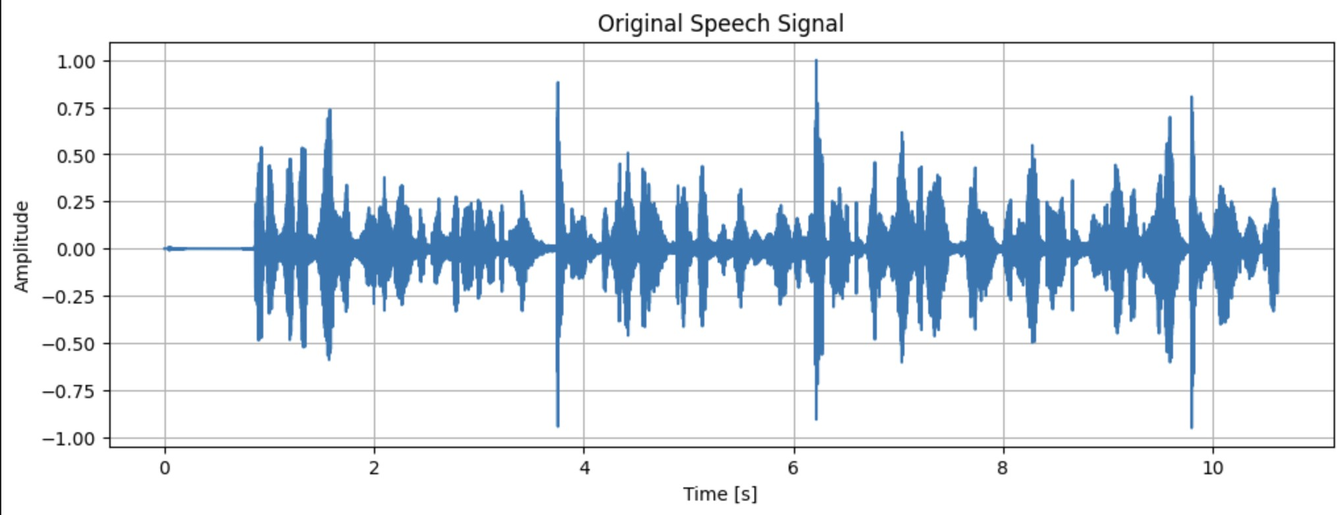
print("Original Audio:")

display(Audio(signal_orig, rate=fs_orig))

Output :
sampling_rates = [8000, 16000, 44100] sampled_signals = {}

for fs_new in sampling_rates:

t_new = np.arange(0, len(signal_orig)/fs_orig, 1/fs_new) sampled_signal = np.interp(t_new, t_orig, signal_orig)
sampled_signals[fs_new] = (t_new, sampled_signal)
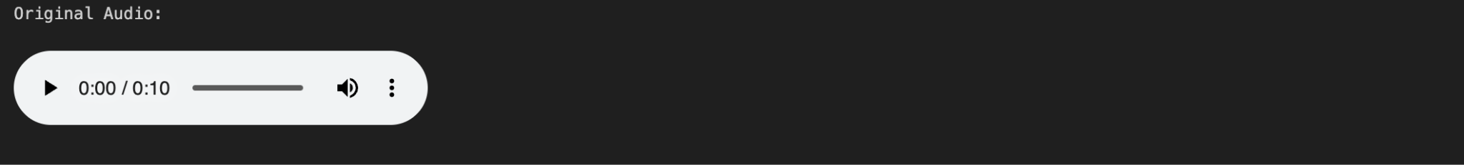

plt.figure(figsize=(12, 8))

for i, (fs_new, (t_new, sampled_signal)) in enumerate(sampled_signals.items(), 1): plt.subplot(3, 1, i)
plt.plot(t_orig, signal_orig, label="Original", alpha=0.7)

plt.plot(t_new, sampled_signal, 'r--', label=f"Sampled @ {fs_new/1000:.1f} kHz") plt.title(f"Original vs Sampled Signal @ {fs_new} Hz")
plt.xlabel("Time [s]") plt.ylabel("Amplitude")
plt.legend(loc="upper right")

plt.tight_layout() plt.show()

Output :
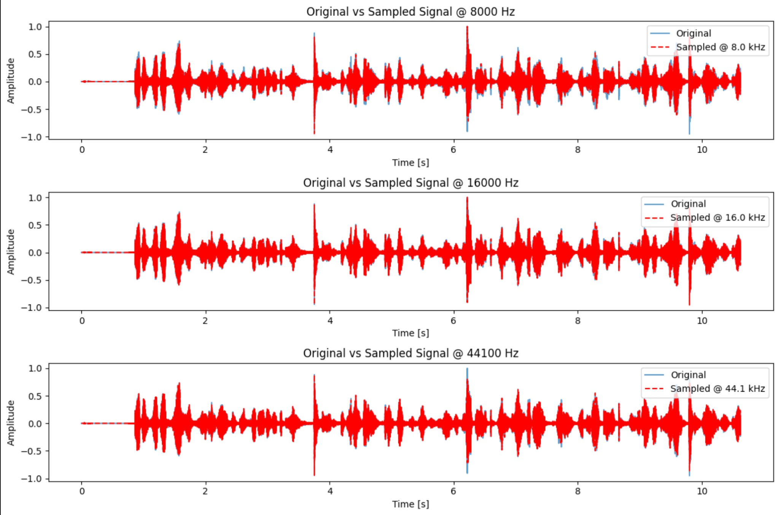
reconstructed_signals = {}

for fs_new in sampling_rates:

t_sampled, sampled_signal = sampled_signals[fs_new]
# Zero-order hold

f_zero = interp1d(t_sampled,
sampled_signal,
kind='nearest',
fill_value="extrapolate")

signal_recon_zero = f_zero(t_orig)
# Linear interpolation
f_linear
=
interp1d(t_sampled,
sampled_signal,
kind='linear',
fill_value="extrapolate")

signal_recon_linear = f_linear(t_orig)
reconstructed_signals[fs_new] = { 'zero': signal_recon_zero, 'linear': signal_recon_linear
}

plt.figure(figsize=(12, 6))

for i, fs_new in enumerate(sampling_rates):

plt.subplot(len(sampling_rates), 2, 2*i+1)

plt.plot(t_orig, reconstructed_signals[fs_new]['zero']) plt.title(f"Zero-Order at {fs_new} Hz")
plt.xlabel("Time [s]") plt.ylabel("Amplitude") plt.grid(True)

plt.subplot(len(sampling_rates), 2, 2*i+2)

plt.plot(t_orig, reconstructed_signals[fs_new]['linear']) plt.title(f"Linear at {fs_new} Hz")
plt.xlabel("Time [s]")

plt.ylabel("Amplitude") plt.grid(True)
plt.tight_layout() plt.show()

Output :
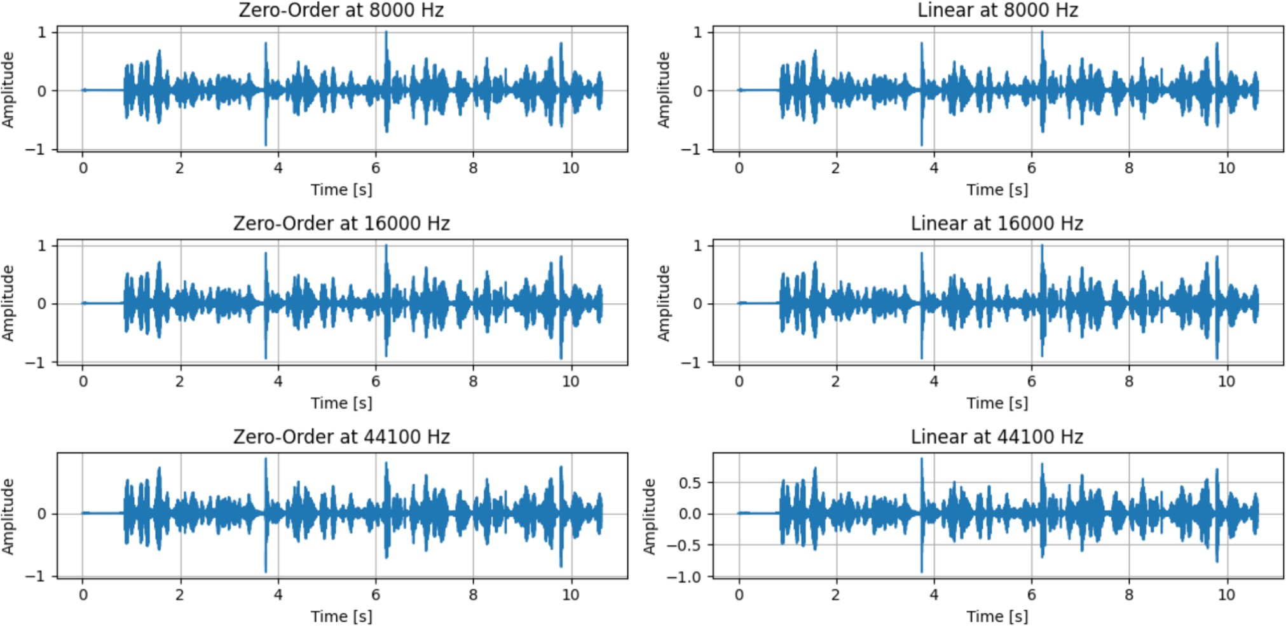
print("Mean Squared Error (MSE):") for fs_new in sampling_rates:
mse_zero
reconstructed_signals[fs_new]['zero'])
=
mean_squared_error(signal_orig,
mse_linear
reconstructed_signals[fs_new]['linear'])
=
mean_squared_error(signal_orig,
print(f"Sampling Rate: {fs_new} Hz | Zero-Order MSE: {mse_zero:.6f} | Linear
MSE: {mse_linear:.6f}")

for fs_new in sampling_rates:

print(f"\nAudio Playback at {fs_new} Hz") print("Zero-Order Hold:")
display(Audio(reconstructed_signals[fs_new]['zero'], rate=fs_orig)) print("Linear Interpolation:")
display(Audio(reconstructed_signals[fs_new]['linear'], rate=fs_orig))

Output :
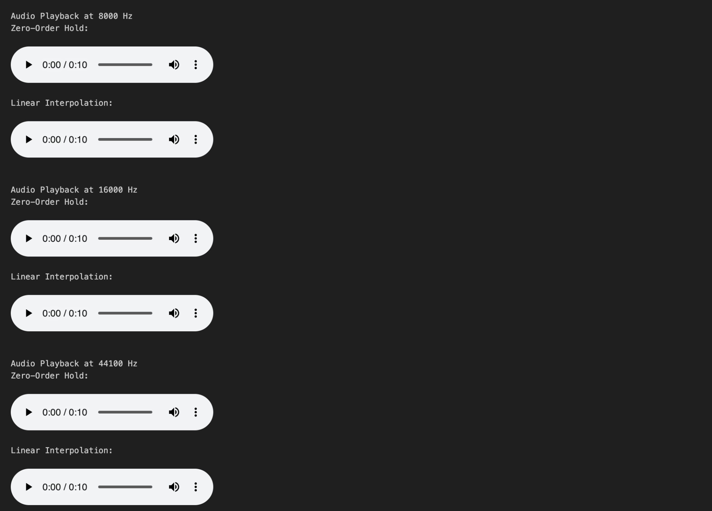
t_orig = np.arange(len(signal_orig)) / fs_orig

fs_sampled = 8000

t_sampled = np.arange(0, len(signal_orig)/fs_orig, 1/fs_sampled) sampled_signal = np.interp(t_sampled, t_orig, signal_orig)

f_cubic
=
interp1d(t_sampled,
sampled_signal,
kind='cubic',
fill_value="extrapolate")

signal_recon_cubic = f_cubic(t_orig)

plt.figure(figsize=(12, 4))

plt.plot(t_orig, signal_orig, label='Original', alpha=0.6)

plt.plot(t_orig, signal_recon_cubic, label='Cubic Reconstruction', alpha=0.8)

plt.scatter(t_sampled, sampled_signal, color='red', s=10, label='Sampled Points') plt.title("Original vs Cubic Reconstruction")
plt.xlabel("Time [s]") plt.ylabel("Amplitude") plt.legend()
plt.grid(True) plt.show()

Output :
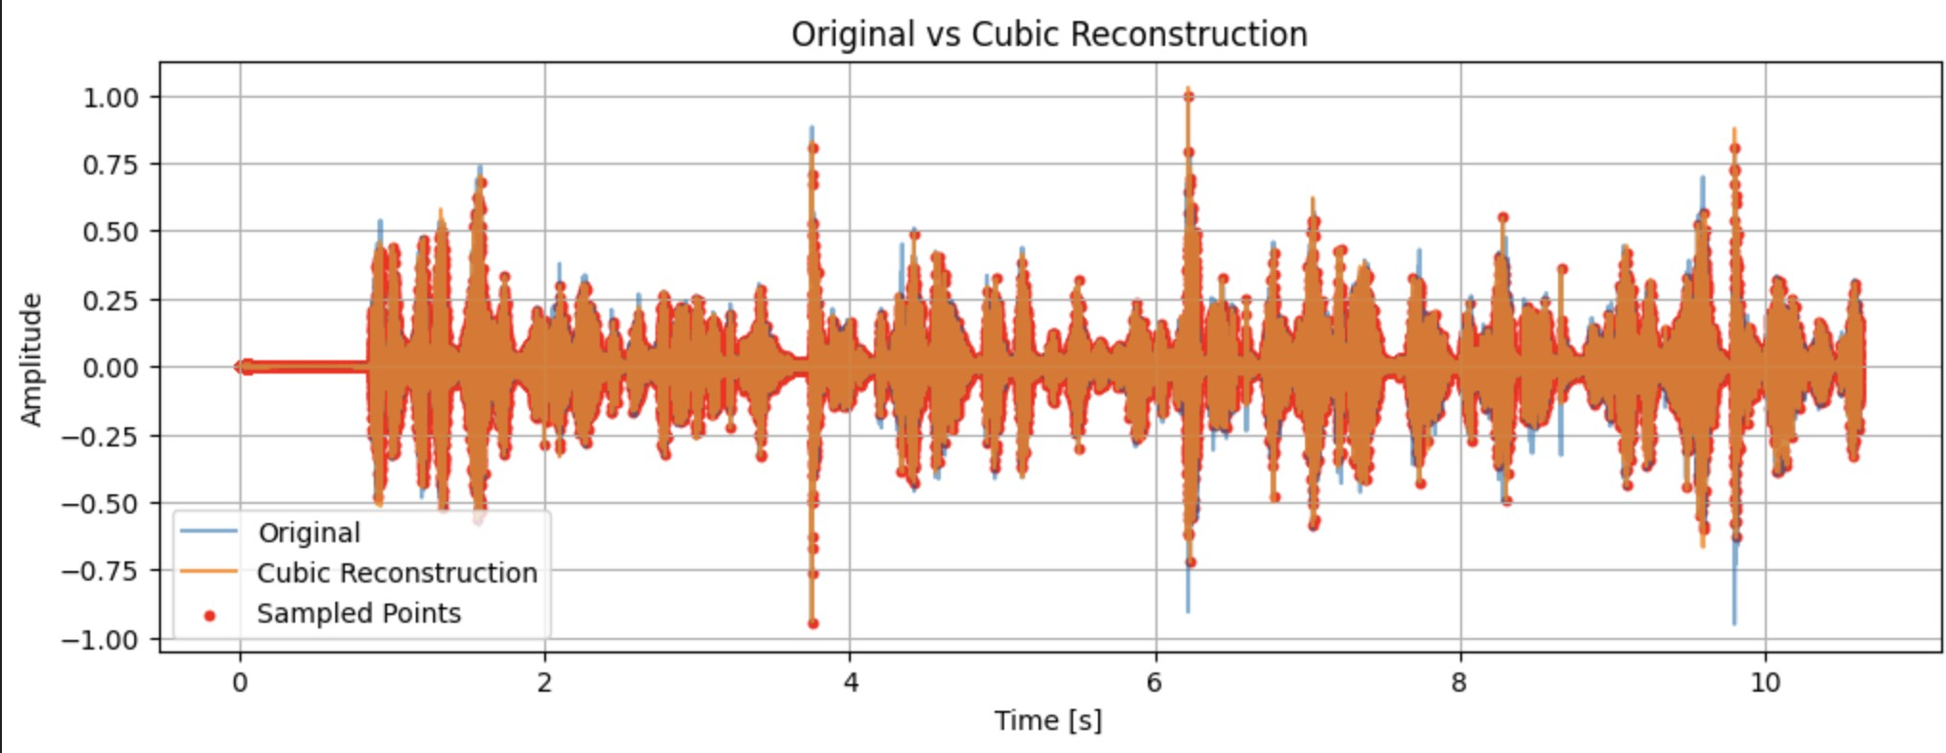
mse_cubic = mean_squared_error(signal_orig, signal_recon_cubic) print(f"Cubic Interpolation MSE: {mse_cubic:.6f}")

Output :

import numpy as np

import matplotlib.pyplot as plt from scipy import signal
from scipy.io import wavfile

def generate_glottal_pulse(duration, sample_rate, fundamental_freq):

t = np.linspace(0, duration, int(sample_rate * duration), endpoint=False)

# Create pulse train for voiced sounds pulse_train = np.zeros_like(t)
pulse_period = int(sample_rate / fundamental_freq)

# Create a more realistic glottal pulse shape for i in range(0, len(t), pulse_period):
if i + pulse_period <= len(t):

# Rosenberg glottal pulse model

pulse_width = int(pulse_period * 0.4) for j in range(pulse_width):
if j < pulse_width * 0.6:

pulse_train[i + j] = 0.5 * (1 - np.cos(np.pi * j / (pulse_width
* 0.6)))

else:

pulse_train[i + j] = np.cos(np.pi * (j - pulse_width * 0.6) /
(pulse_width * 0.4))
print("Cubic Interpolation Audio:")

display(Audio(signal_recon_cubic, rate=fs_orig))

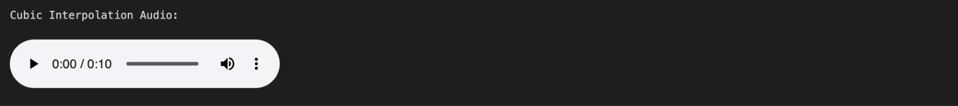

return pulse_train, t

def generate_noise(duration, sample_rate): """Generate noise for unvoiced sounds"""
t = np.linspace(0, duration, int(sample_rate * duration), endpoint=False) noise = np.random.normal(0, 1, len(t))

# Apply fade in/out to avoid clicks

fade_samples = int(0.01 * sample_rate)

noise[:fade_samples] *= np.linspace(0, 1, fade_samples) noise[-fade_samples:] *= np.linspace(1, 0, fade_samples)

return noise, t

def design_formant_filter(frequencies, bandwidths, sample_rate, gain=1.0): """Design a formant filter using second-order sections"""
sos = []

for f, bw in zip(frequencies, bandwidths): omega = 2 * np.pi * f / sample_rate
bw_digital = 2 * np.pi * bw / sample_rate

r = np.exp(-bw_digital / 2) theta = omega

b = [gain ** (1/len(frequencies))]

a = [1, -2 * r * np.cos(theta), r * r]

sos.append([b[0], 0, 0, a[0], a[1], a[2]])

return np.array(sos)

def apply_formant_filter(input_signal, sos, sample_rate):

"""Apply formant filter to input signal""" output = input_signal.copy()

# Apply each formant filter in cascade for section in sos:
b = section[0:3] a = section[3:6]
output = signal.lfilter(b, a, output)

return output

def synthesize_phoneme(phoneme_type, duration, sample_rate, fundamental_freq=None): """Synthesize a single phoneme"""

if phoneme_type == 'silence':

return np.zeros(int(sample_rate * duration))

elif phoneme_type == 'voiced':

excitation, t = generate_glottal_pulse(duration, sample_rate, fundamental_freq)

elif phoneme_type == 'unvoiced':

excitation, t = generate_noise(duration, sample_rate)

else:

raise ValueError(f"Unknown phoneme type: {phoneme_type}")

return excitation

def synthesize_word_transformers(sample_rate=16000, fundamental_freq=120): """Synthesize the word 'transformers' using source-filter model"""

phonemes = [

{'type': 'unvoiced', 'duration': 0.08, 'formants': []},

{'type': 'voiced', 'duration': 0.1, 'formants': [600, 1200, 2400]},

{'type': 'voiced', 'duration': 0.15, 'formants': [700, 1800, 2500]},

{'type': 'voiced', 'duration': 0.1, 'formants': [250, 1700, 2300]},

{'type': 'unvoiced', 'duration': 0.15, 'formants': [4000, 5000, 6000]},

{'type': 'unvoiced', 'duration': 0.1, 'formants': []},

{'type': 'voiced', 'duration': 0.2, 'formants': [500, 1000, 2500]},

{'type': 'voiced', 'duration': 0.1, 'formants': [250, 1700, 2300]},

{'type': 'voiced', 'duration': 0.15, 'formants': [500, 1500, 2500]},

{'type': 'unvoiced', 'duration': 0.2, 'formants': [4000, 5000, 6000]}

]

bandwidths = [80, 100, 120] synthesized_audio = []

for i, phoneme in enumerate(phonemes):

print(f"Synthesizing phoneme {i+1}: {phoneme['type']}")

if phoneme['type'] == 'voiced':

excitation = synthesize_phoneme('voiced', phoneme['duration'], sample_rate, fundamental_freq)
else:

excitation = synthesize_phoneme('unvoiced', phoneme['duration'],
sample_rate)

if phoneme['formants']:

sos = design_formant_filter(phoneme['formants'], bandwidths,
sample_rate)

filtered_signal = apply_formant_filter(excitation, sos, sample_rate) else:
filtered_signal = excitation

synthesized_audio.append(filtered_signal)

full_audio = np.concatenate(synthesized_audio)

full_audio = full_audio / np.max(np.abs(full_audio)) * 0.8

return full_audio

def plot_signals(signal_array, sample_rate, title):

"""Plot the synthesized signal in time and frequency domains"""

t = np.linspace(0, len(signal_array)/sample_rate, len(signal_array))

fig, (ax1, ax2) = plt.subplots(2, 1, figsize=(12, 8))

ax1.plot(t, signal_array)

ax1.set_title(f'{title} - Time Domain') ax1.set_xlabel('Time (s)')
ax1.set_ylabel('Amplitude') ax1.grid(True)

f, Pxx = signal.welch(signal_array, sample_rate, nperseg=1024) ax2.semilogy(f, Pxx)
ax2.set_title(f'{title} - Frequency Domain') ax2.set_xlabel('Frequency (Hz)')
ax2.set_ylabel('Power Spectral Density') ax2.grid(True)
ax2.set_xlim(0, 6000)

plt.tight_layout() plt.show()

# Main execution

if name == " main ": # Parameters
SAMPLE_RATE = 16000

FUNDAMENTAL_FREQ = 120 # Hz (pitch for voiced sounds)

# Synthesize the word "transformers" print("Synthesizing the word 'transformers'...")
transformers_audio = synthesize_word_transformers(SAMPLE_RATE, FUNDAMENTAL_FREQ)

# Plot the results

plot_signals(transformers_audio, SAMPLE_RATE, "Synthesized Word 'transformers'")

# Save as WAV file

wavfile.write("synthesized_transformers.wav", SAMPLE_RATE, (transformers_audio * 32767).astype(np.int16))

print("Synthesis complete! Audio saved as 'synthesized_transformers.wav'")

Output :

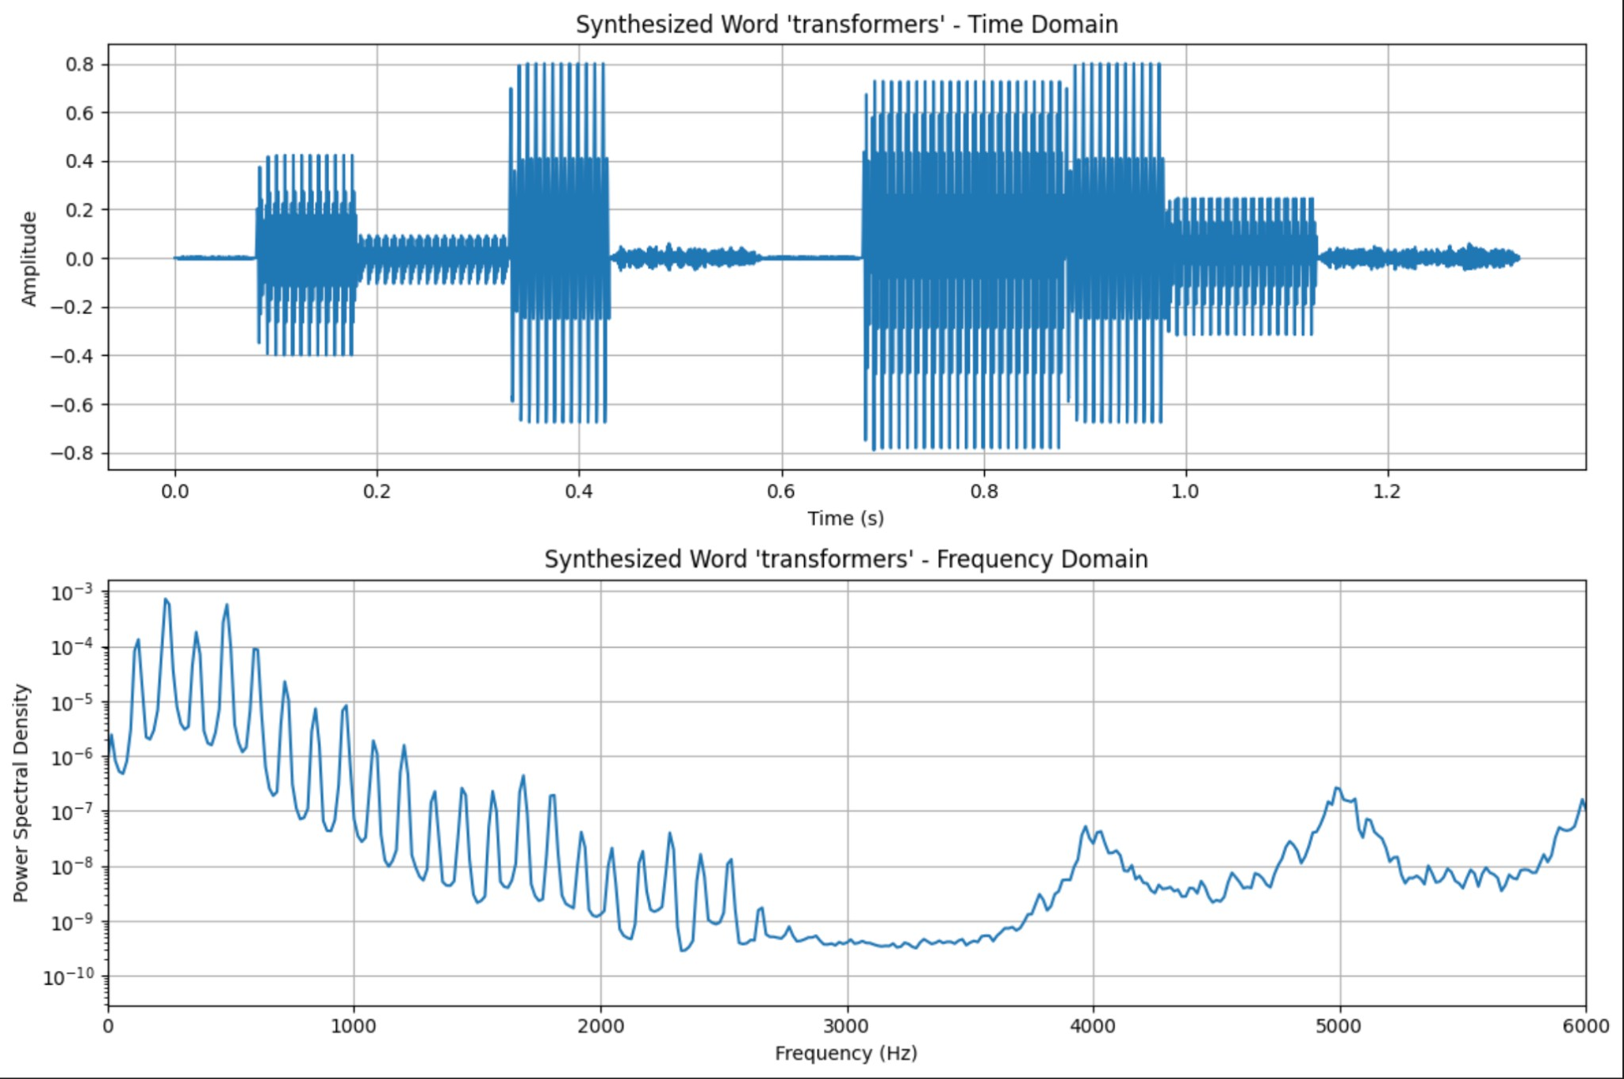
from IPython.display import Audio, display

print("\n🎧 Synthesized Audio: 'transformers'") display(Audio(transformers_audio, rate=SAMPLE_RATE))

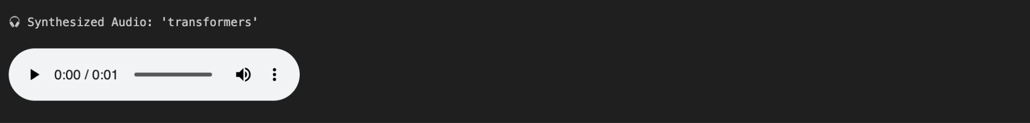
def plot_filter_effects():

"""Plot original source vs filtered signal to analyze filter effects"""

# Synthesize a single voiced phoneme for analysis duration = 0.1
sample_rate = 16000

fundamental_freq = 120

# Generate excitation source

excitation, t = generate_glottal_pulse(duration, sample_rate, fundamental_freq)

# Design formant filter (vowel 'a' formants) formant_freqs = [700, 1220, 2600]
bandwidths = [80, 100, 120]

sos = design_formant_filter(formant_freqs, bandwidths, sample_rate)

# Apply filter

filtered_signal = apply_formant_filter(excitation, sos, sample_rate)

# Plot comparison

fig, ((ax1, ax2), (ax3, ax4)) = plt.subplots(2, 2, figsize=(15, 10))

# Time domain - excitation ax1.plot(t, excitation)
ax1.set_title('Glottal Pulse Excitation (Time Domain)') ax1.set_xlabel('Time (s)')
ax1.set_ylabel('Amplitude') ax1.grid(True)

# Time domain - filtered

ax2.plot(t, filtered_signal)

ax2.set_title('Filtered Speech Signal (Time Domain)') ax2.set_xlabel('Time (s)')
ax2.set_ylabel('Amplitude') ax2.grid(True)

# Frequency domain - excitation

f_exc, Pxx_exc = signal.welch(excitation, sample_rate, nperseg=1024) ax3.semilogy(f_exc, Pxx_exc)
ax3.set_title('Excitation Spectrum')

ax3.set_xlabel('Frequency (Hz)')

ax3.set_ylabel('Power Spectral Density') ax3.grid(True)
ax3.set_xlim(0, 4000)

# Frequency domain - filtered

f_filt, Pxx_filt = signal.welch(filtered_signal, sample_rate, nperseg=1024) ax4.semilogy(f_filt, Pxx_filt)
ax4.set_title('Filtered Signal Spectrum (Formants Visible)') ax4.set_xlabel('Frequency (Hz)')
ax4.set_ylabel('Power Spectral Density') ax4.grid(True)
ax4.set_xlim(0, 4000)

# Mark formant frequencies for freq in formant_freqs:
ax4.axvline(x=freq, color='red', linestyle='--', alpha=0.7, label=f'Formant
{freq}Hz')

plt.tight_layout() plt.show()

print("Filter Analysis:")

print("- Formant frequencies add resonant peaks to the spectrum") print("- Excitation spectrum is relatively flat")
print("- Filter shapes the spectral envelope to create vowel sounds")

print("- Time domain shows how pulse train is smoothed by vocal tract filter")

plot_filter_effects()

Output :

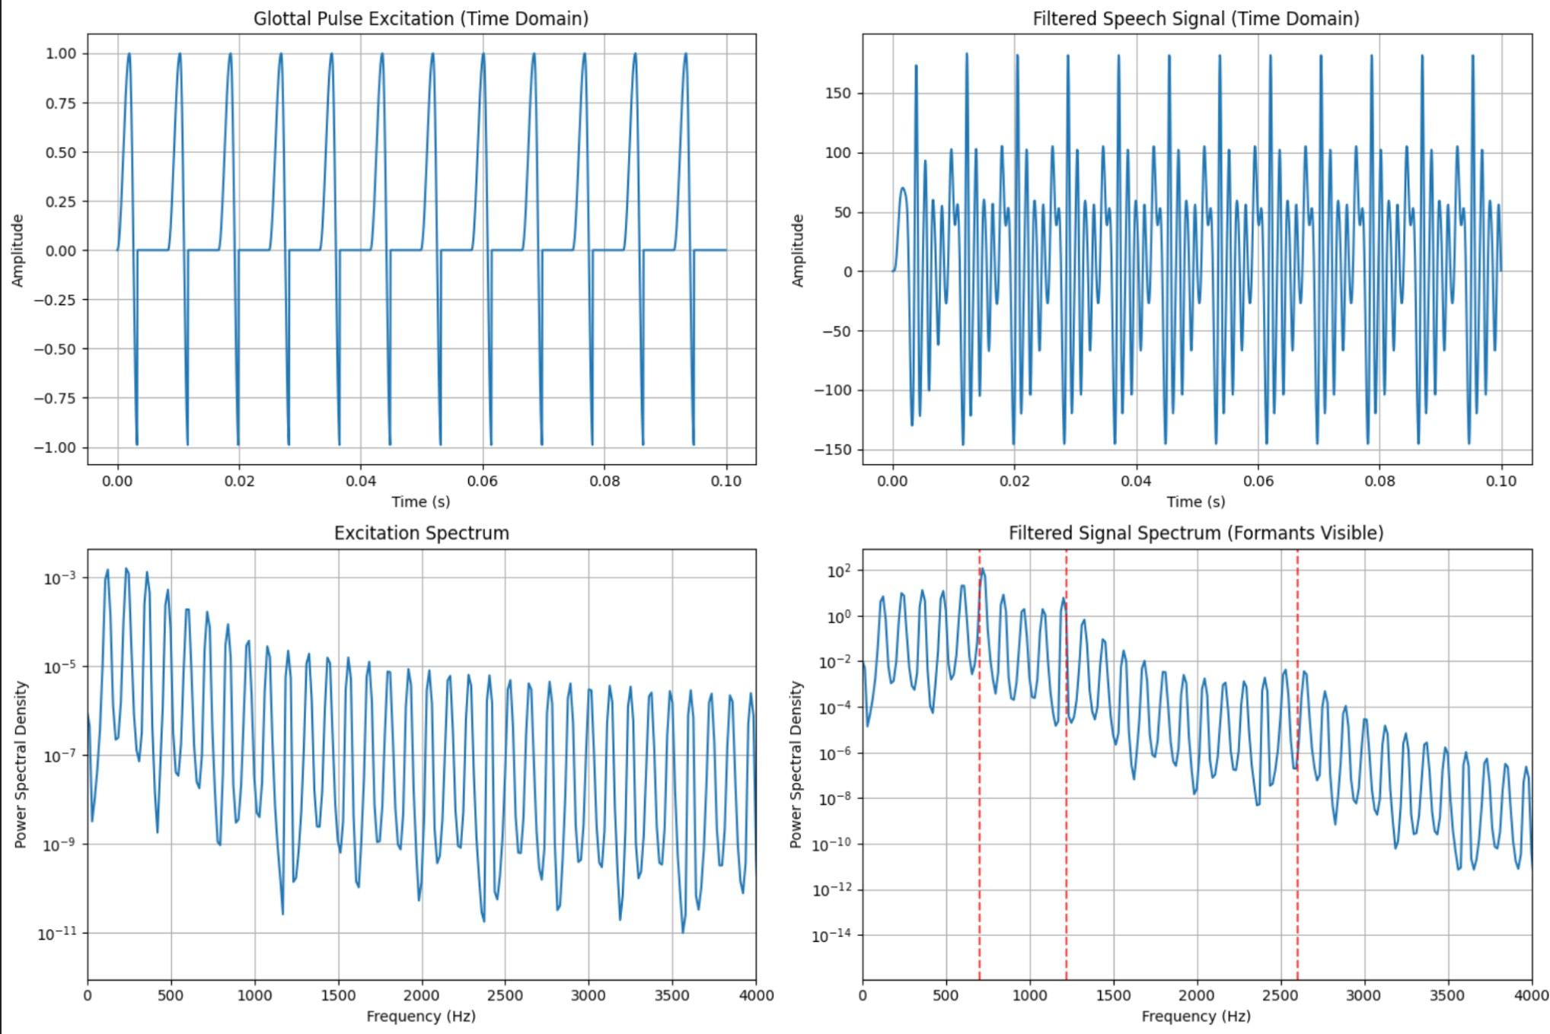
def sample_at_different_rates():
# Generate original signal
original_signal = synthesize_word_transformers() original_rate = 16000
t_original
len(original_signal))
=
np.linspace(0,
len(original_signal)/original_rate,
# Target sampling rates

target_rates = [8000, 16000, 44100]
# Dictionary to store resampled signals

resampled_signals = {}
for target_rate in target_rates:

# Calculate number of samples for target rate (same duration)

num_samples = int(len(original_signal) * target_rate / original_rate)

# Resample using Fourier method (preserves frequency content better) resampled = signal.resample(original_signal, num_samples)
resampled_signals[target_rate] = resampled

print(f"Original: {len(original_signal)} samples at {original_rate}Hz") print(f"Resampled: {len(resampled)} samples at {target_rate}Hz")

# Plot comparison

t_resampled = np.linspace(0, len(resampled)/target_rate, len(resampled))

plt.figure(figsize=(12, 4))

plt.plot(t_original, original_signal, 'b-', alpha=0.7, label=f'Original
{original_rate}Hz')

plt.plot(t_resampled, resampled, 'r-', alpha=0.8, label=f'Resampled
{target_rate}Hz')

plt.title(f'Signal Sampled at {target_rate}Hz') plt.xlabel('Time (s)')
plt.ylabel('Amplitude') plt.legend()
plt.grid(True) plt.show()

return resampled_signals, original_signal

# Sample at different rates

resampled_signals, original_signal = sample_at_different_rates()

Output :

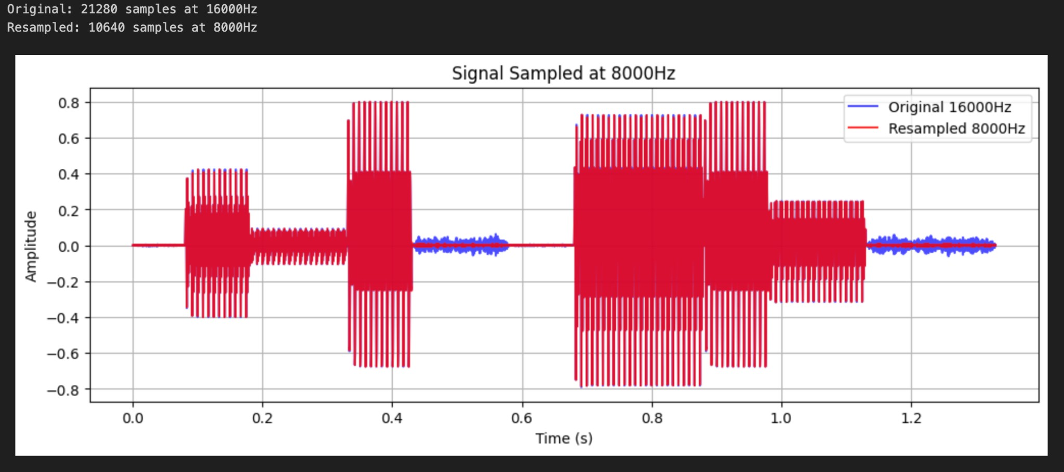
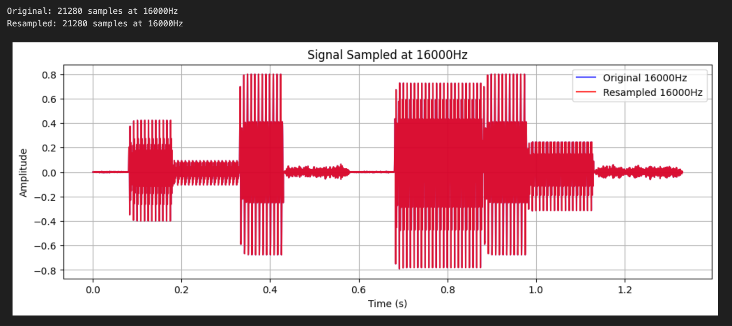
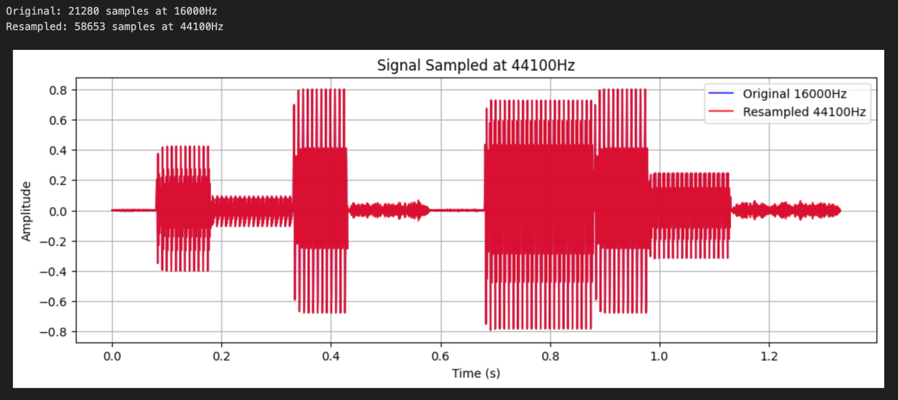

import numpy as np

import matplotlib.pyplot as plt from scipy import signal
from scipy.io import wavfile

from scipy.interpolate import CubicSpline from IPython.display import Audio, display

def reconstruct_with_interpolation_alternative():

"""Reconstruct signal using Zero-Order Hold, Linear, and Cubic Interpolation, and display audio players for manual playback."""

# Parameters

original_rate = 16000

downsampled_rate = 8000

# Generate original signal (replace this with your actual synthesis function) original_signal = synthesize_word_transformers(sample_rate=original_rate)

# Downsample

num_samples_down = int(len(original_signal) * downsampled_rate / original_rate) downsampled_signal = signal.resample(original_signal, num_samples_down)

# Time vectors

t_original = np.linspace(0, len(original_signal)/original_rate, len(original_signal))
t_downsampled = np.linspace(0, len(downsampled_signal)/downsampled_rate, len(downsampled_signal))

# Reconstruction methods

reconstruction_methods = {}

# 1. Zero-order hold (nearest neighbor)

zoh_signal = np.zeros_like(original_signal) for i in range(len(original_signal)):
idx = int(i * len(downsampled_signal) / len(original_signal)) idx = min(idx, len(downsampled_signal)-1)
zoh_signal[i] = downsampled_signal[idx]

reconstruction_methods['Zero-Order Hold'] = zoh_signal

# 2. Linear interpolation

linear_signal = np.interp(t_original, t_downsampled, downsampled_signal) reconstruction_methods['Linear Interpolation'] = linear_signal

# 3. Cubic interpolation

cubic_spline = CubicSpline(t_downsampled, downsampled_signal) cubic_signal = cubic_spline(t_original)
reconstruction_methods['Cubic Interpolation'] = cubic_signal

# Plotting all 3 methods

plt.figure(figsize=(12, 15))

# Plot 1: Zero-Order Hold plt.subplot(3, 1, 1)
plt.plot(t_original[1000:1500], original_signal[1000:1500],

'b-', linewidth=2, label='Original 16kHz', alpha=0.8)

plt.plot(t_downsampled, downsampled_signal, 'ro', markersize=4, label='Downsampled 8kHz')
plt.plot(t_original[1000:1500], zoh_signal[1000:1500],

'g--', linewidth=1.5, label='Reconstructed (Zero-Order Hold)') plt.title('Reconstruction: Zero-Order Hold')
plt.xlabel('Time (s)') plt.ylabel('Amplitude') plt.legend()
plt.grid(True)

# Plot 2: Linear Interpolation plt.subplot(3, 1, 2)
plt.plot(t_original[1000:1500], original_signal[1000:1500],

'b-', linewidth=2, label='Original 16kHz', alpha=0.8)

plt.plot(t_downsampled, downsampled_signal, 'ro', markersize=4, label='Downsampled 8kHz')
plt.plot(t_original[1000:1500], linear_signal[1000:1500],

'g--', linewidth=1.5, label='Reconstructed (Linear Interpolation)') plt.title('Reconstruction: Linear Interpolation')
plt.xlabel('Time (s)') plt.ylabel('Amplitude') plt.legend()
plt.grid(True)

# Plot 3: Cubic Interpolation plt.subplot(3, 1, 3)
plt.plot(t_original[1000:1500], original_signal[1000:1500],

'b-', linewidth=2, label='Original 16kHz', alpha=0.8)

plt.plot(t_downsampled, downsampled_signal, 'ro', markersize=4, label='Downsampled 8kHz')
plt.plot(t_original[1000:1500], cubic_signal[1000:1500],

'g--', linewidth=1.5, label='Reconstructed (Cubic Interpolation)') plt.title('Reconstruction: Cubic Interpolation')
plt.xlabel('Time (s)') plt.ylabel('Amplitude') plt.legend()
plt.grid(True)

plt.tight_layout() plt.show()

# Save audio files

print("\nSaving audio files for playback...")

wavfile.write("original_16khz.wav", original_rate, (original_signal * 32767).astype(np.int16))

for method, reconstructed in reconstruction_methods.items():

filename = f"reconstructed_{method.replace(' ', '_').lower()}.wav"

wavfile.write(filename, original_rate, (reconstructed * 32767).astype(np.int16))
print(f"Saved: {filename}")

print("\n✅ Audio files saved. You can play them below:")

# --- Display Audio Players --- print("\n🎧 Original Audio:")
display(Audio(original_signal, rate=original_rate))

print("\n🎧 Reconstructed (Zero-Order Hold):")

display(Audio(reconstruction_methods['Zero-Order Hold'], rate=original_rate))

print("\n🎧 Reconstructed (Linear Interpolation):")

display(Audio(reconstruction_methods['Linear Interpolation'], rate=original_rate))

print("\n🎧 Reconstructed (Cubic Interpolation):")

display(Audio(reconstruction_methods['Cubic Interpolation'], rate=original_rate))

return reconstruction_methods, original_signal, downsampled_signal, original_rate

# --- Run Function ---

reconstruction_methods,
original_signal,
downsampled_signal,
fs_orig
=
reconstruct_with_interpolation_alternative()

Output :
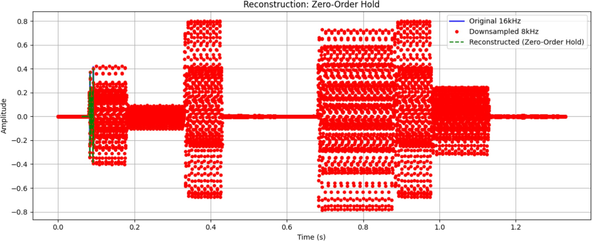

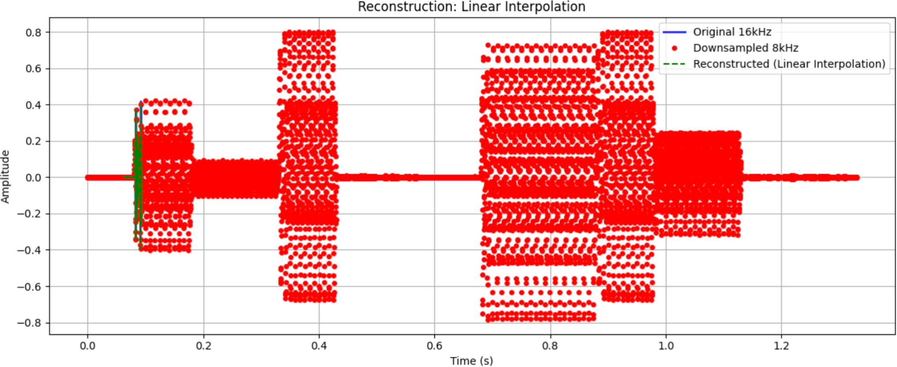

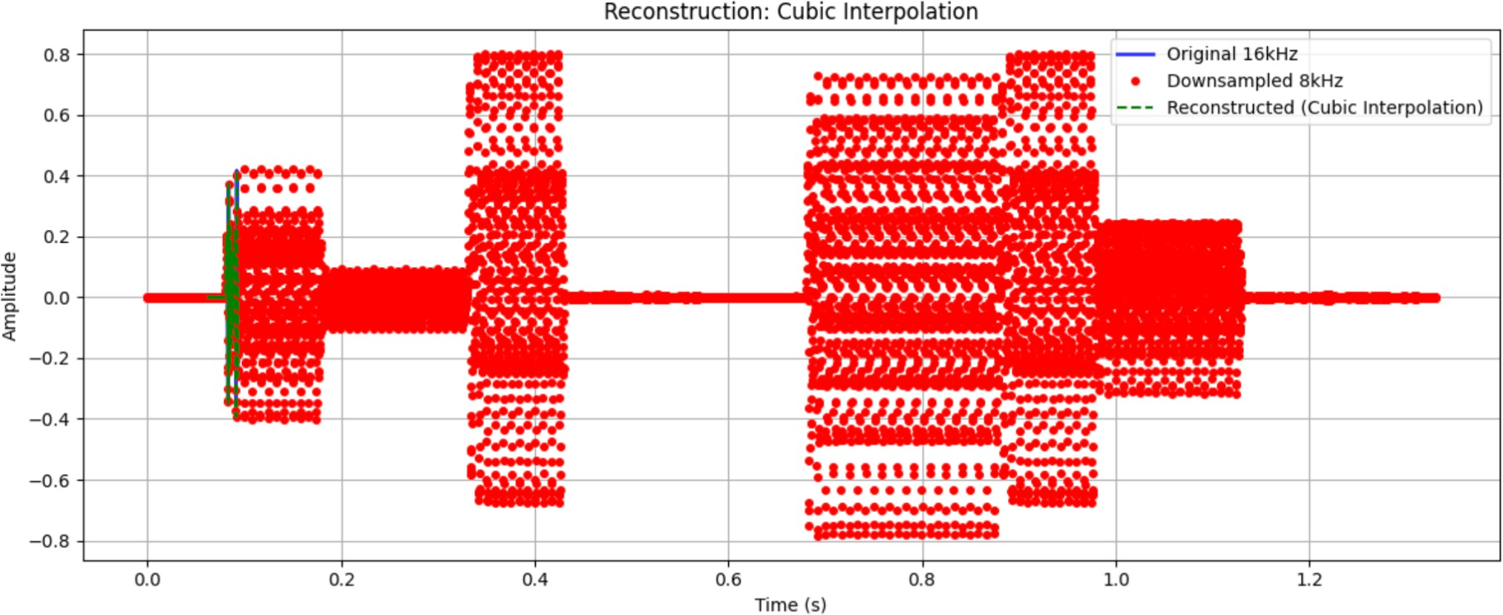
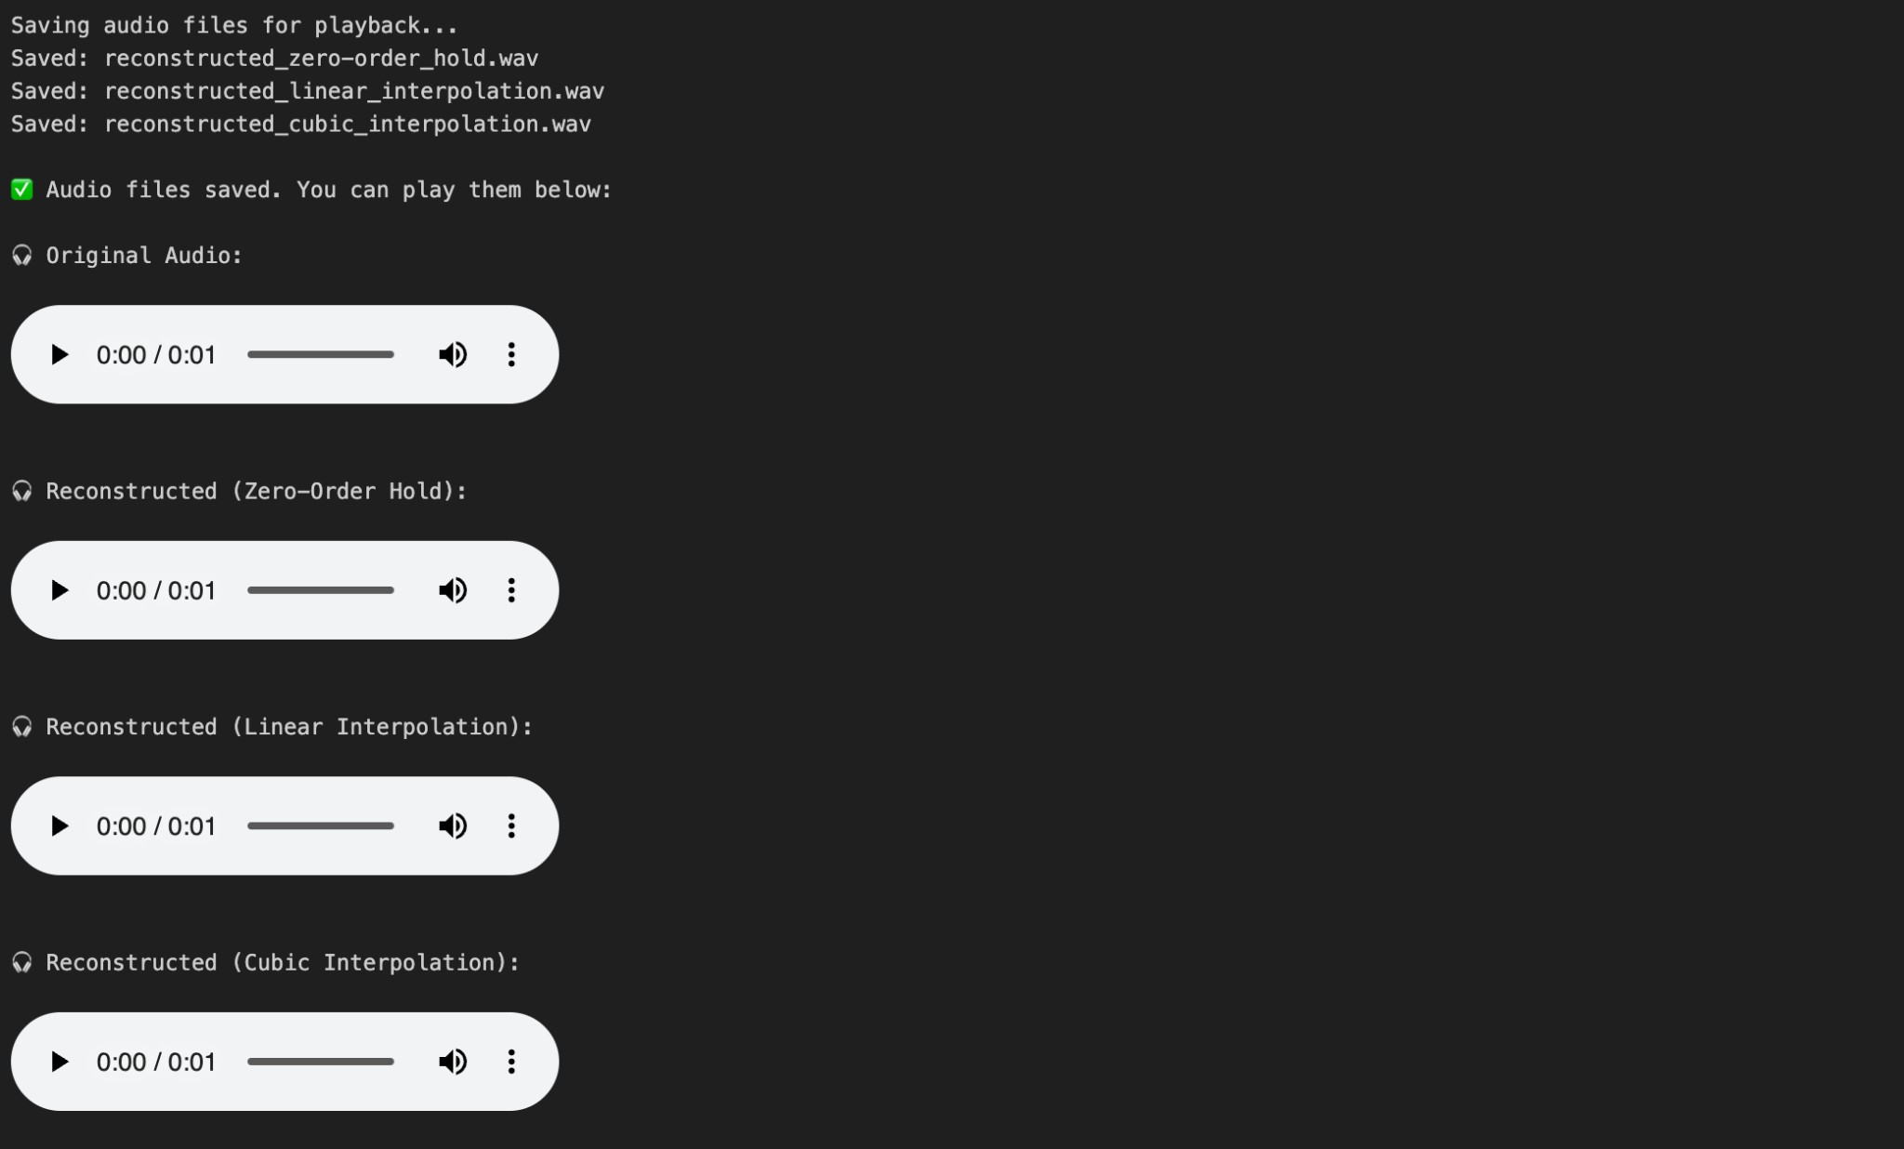
import numpy as np

import matplotlib.pyplot as plt

def compute_mse(original_signal, reconstructed_signal): # Ensure both signals have the same length
min_length = min(len(original_signal), len(reconstructed_signal)) original_trunc = original_signal[:min_length]
reconstructed_trunc = reconstructed_signal[:min_length]

# Compute Mean Squared Error

mse = np.mean((original_trunc - reconstructed_trunc) ** 2)

return mse

def compute_mse_comparison(original_signal, reconstructed_signals):

print("MSE BETWEEN ORIGINAL AND RECONSTRUCTED SPEECH SIGNALS")

print("=" * 60)

mse_results = {}

for method_name, reconstructed in reconstructed_signals.items(): mse = compute_mse(original_signal, reconstructed)
mse_results[method_name] = mse

# Additional metrics rmse = np.sqrt(mse)
min_length = min(len(original_signal), len(reconstructed)) signal_power = np.mean(original_signal[:min_length] ** 2)
snr = 10 * np.log10(signal_power / mse) if mse > 0 else float('inf')

print(f"Method: {method_name}") print(f" MSE: {mse:.8f}")
print(f" RMSE: {rmse:.8f}")

print(f" SNR: {snr:.2f} dB") print()

return mse_results

def plot_mse_results(mse_results):

"""Plot MSE results as a bar chart""" plt.figure(figsize=(10, 6))
methods = list(mse_results.keys())

mse_values = list(mse_results.values())

bars = plt.bar(methods, mse_values, color=['skyblue', 'lightcoral', 'lightgreen', 'gold'])
plt.title('Mean Squared Error (MSE): Original vs Reconstructed Signals') plt.ylabel('MSE Value')
plt.xlabel('Reconstruction Method') plt.grid(True, axis='y', alpha=0.3)

# Add value labels on bars

for bar, value in zip(bars, mse_values):

plt.text(bar.get_x() + bar.get_width()/2, bar.get_height() + max(mse_values)*0.01,
f'{value:.6f}', ha='center', va='bottom', fontweight='bold')

plt.tight_layout() plt.show()

# Example usage with your speech signals:

def run_complete_mse_analysis():

# Generate your signals first (using your existing functions)

original_signal = synthesize_word_transformers(sample_rate=16000)

# Create reconstructed signals (example with different methods) reconstructed_signals = {}

# Example reconstruction methods - replace with your actual reconstructed signals
# Zero-order hold reconstruction

downsampled_rate = 8000

num_samples_down = int(len(original_signal) * downsampled_rate / 16000) downsampled_signal = signal.resample(original_signal, num_samples_down)

# Zero-order hold

zoh_signal = np.zeros_like(original_signal) for i in range(len(original_signal)):
idx = int(i * len(downsampled_signal) / len(original_signal)) idx = min(idx, len(downsampled_signal)-1)
zoh_signal[i] = downsampled_signal[idx]

reconstructed_signals['Zero-Order Hold'] = zoh_signal

# Linear interpolation

t_original = np.linspace(0, len(original_signal)/16000, len(original_signal))

t_downsampled = np.linspace(0, len(downsampled_signal)/downsampled_rate, len(downsampled_signal))
linear_signal = np.interp(t_original, t_downsampled, downsampled_signal) reconstructed_signals['Linear Interpolation'] = linear_signal

# Cubic interpolation

from scipy.interpolate import CubicSpline

cubic_spline = CubicSpline(t_downsampled, downsampled_signal) cubic_signal = cubic_spline(t_original)
reconstructed_signals['Cubic Interpolation'] = cubic_signal

# Compute MSE for all methods

mse_results = compute_mse_comparison(original_signal, reconstructed_signals)

# Plot results plot_mse_results(mse_results)

# Print summary

print("\n" + "="*50) print("SUMMARY") print("="*50)
best_method = min(mse_results, key=mse_results.get)

worst_method = max(mse_results, key=mse_results.get)
print(f"Best reconstruction method: {best_method}")

print(f"Worst reconstruction method: {worst_method}")
print(f"MSE
{mse_results[best_method]:.8f}")
range:
{mse_results[worst_method]:.8f}
to
return mse_results, reconstructed_signals
# Run the analysis

mse_results, reconstructed_signals = run_complete_mse_analysis()

Output :
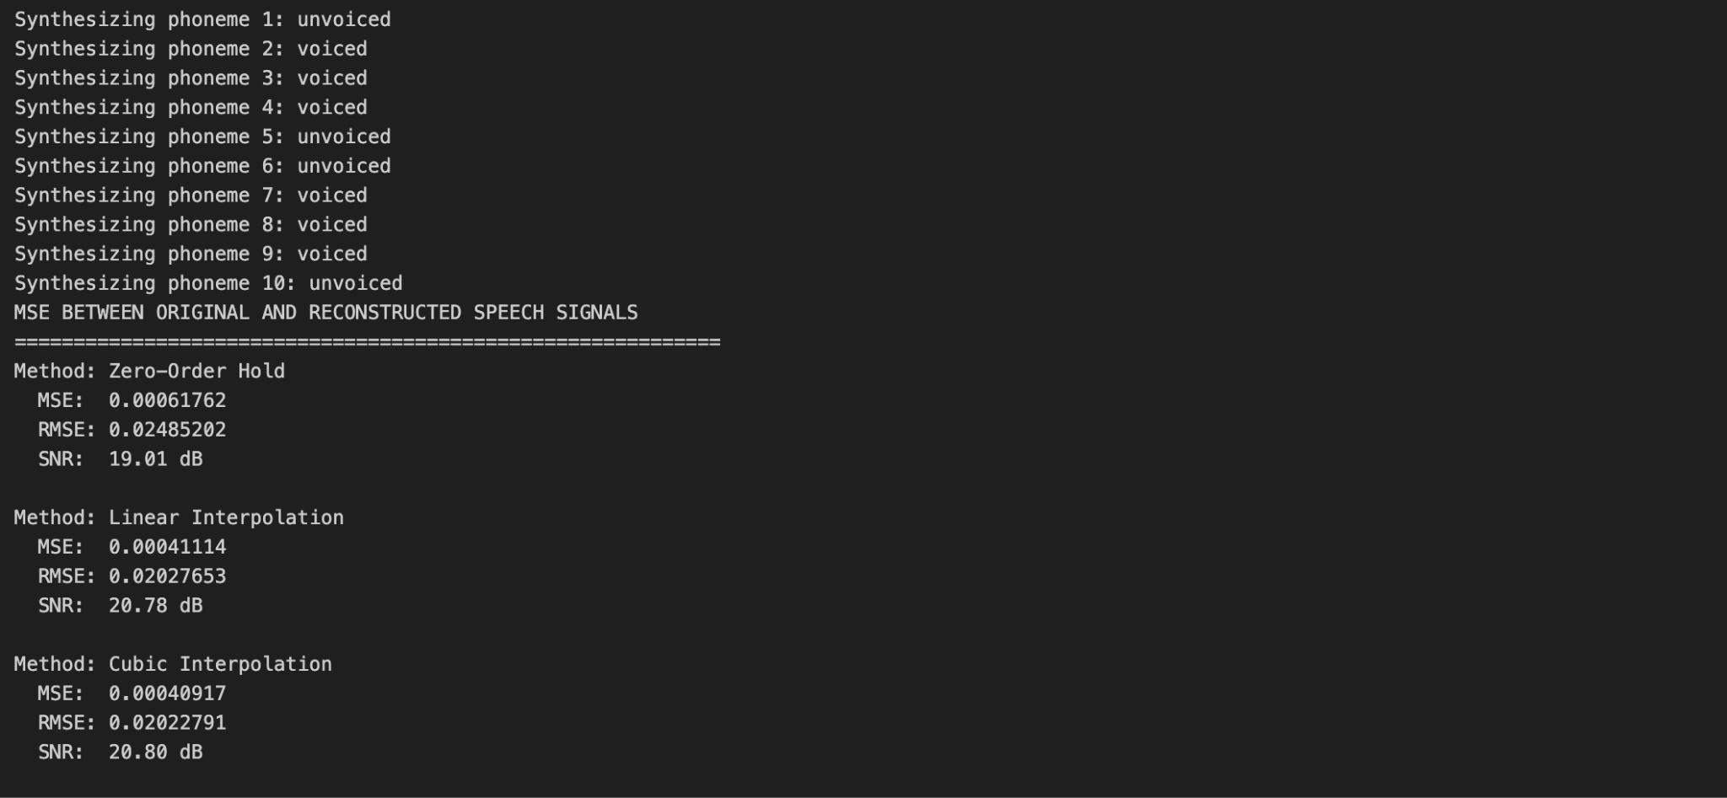

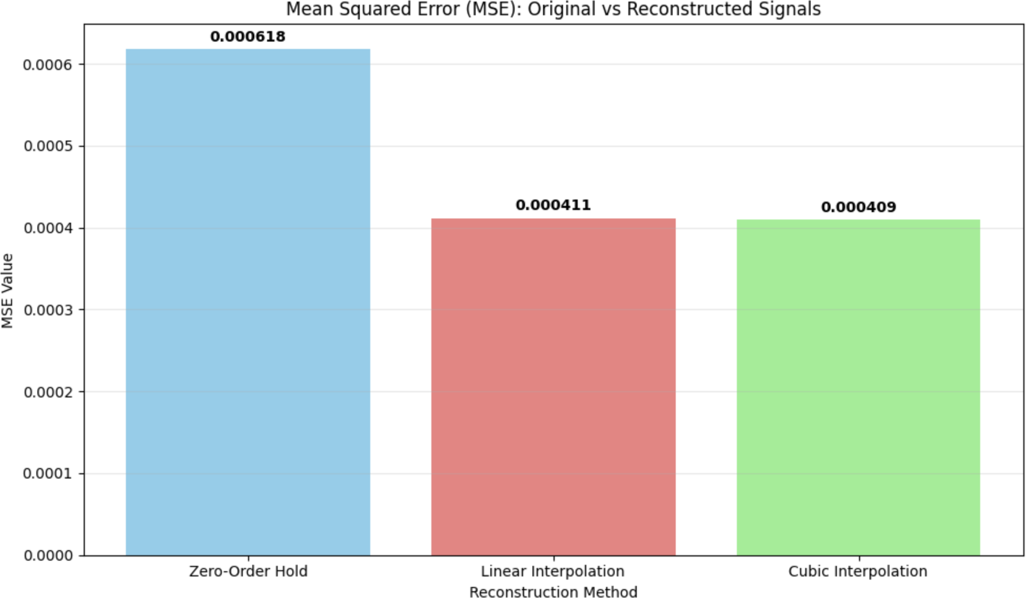

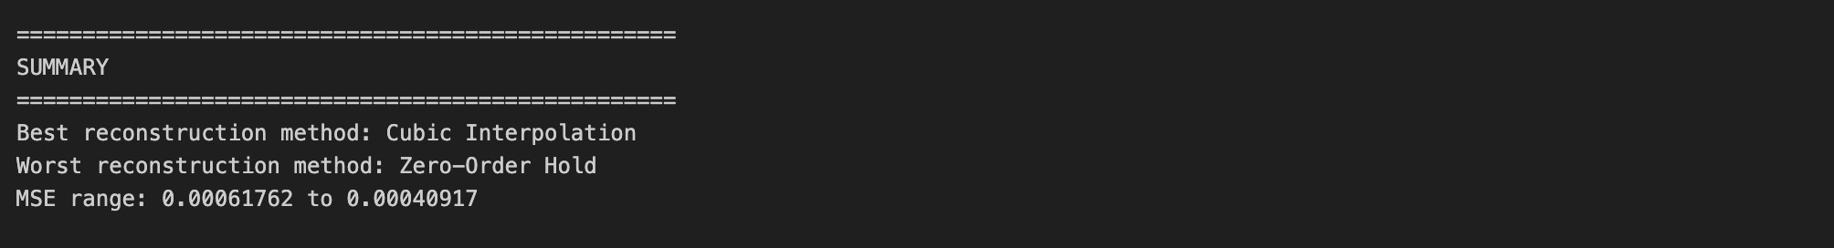

Conclusion /inference :

From the experiment, we can conclude that sampling rate plays a crucial role in the quality of reconstructed speech signals. The chosen rates—8000 Hz, 16000 Hz, and 44100 Hz—are not arbitrary: 8000 Hz is the standard in telephony (narrowband speech), sufficient for transmitting intelligible voice but with limited clarity since it only covers frequencies up to 4 kHz (Nyquist theorem). 16000 Hz is often used in modern speech processing (wideband speech), capturing richer details of human voice up to 8 kHz, improving naturalness and intelligibility. Finally, 44100 Hz is the CD-quality standard, capable of representing audio frequencies up to 22.05 kHz, thus preserving near-original quality. The interpolation results (zero-order, linear, cubic) show that higher sampling rates yield lower reconstruction errors (smaller MSE) and audio closer to the original, while lower rates introduce noticeable

distortion. This demonstrates the trade-off between storage/bandwidth efficiency and audio fidelity in digital signal processing.
From this experiment we can draw the same high-level conclusions as before, but tied to the source–filter synthesis and the specific reconstructions you implemented: the source (glottal pulse or noise) creates the excitation spectrum while the cascade of formant filters sculpts the spectral envelope and produces vowel/resonant peaks — that is what makes the synthesized word “transformers” sound speech-like. Resampling and reconstruction show the familiar trade-offs: 8000 Hz (telephony/narrowband) removes energy above 4 kHz and will lose high-frequency formants and sibilance, 16000 Hz (wideband speech) captures important speech detail up to 8 kHz and is a practical choice for ASR and speech synthesis, and 44100 Hz (CD quality) preserves audio up to ≈22 kHz so it gives the best fidelity. Using a Fourier resampler preserved spectral content better than crude decimation; among reconstruction methods, zero-order hold produces the largest distortion (highest MSE / lowest SNR), linear interpolation is better, and cubic interpolation (or spline) gives the lowest MSE and the most natural sounding result because it better reconstructs the spectral envelope shaped by the formant filters. In short: formant filtering + a sufficiently high sampling rate (16 kHz as a good speech engineering compromise, 44.1 kHz when you need near-studio quality) plus a higher-order interpolation method (cubic) produce the lowest reconstruction error and the most natural synthesized speech; 8 kHz is only appropriate when bandwidth/storage are severely constrained.

Lab Exercise 2:

Fourier Transform and Frequency Spectrum Analysis of Signals

Aim
To study the Fourier Transform and analyze the frequency spectrum of different signals (sinusoidal, composite, exponential, and rectangular). To compare their time-domain representation with their frequency-domain characteristics using both the Discrete-Time Fourier Transform (DTFT) and the Discrete Fourier Transform (DFT).

Questions

Question 1
- Generate a basic sinusoidal signal in the time domain. (For example, generate a sine wave with a frequency of 5 Hz, sampled at 1000 Hz.)
- Plot the time-domain waveform of the signal.
- Compute the Discrete-Time Fourier Transform (DTFT) and plot the continuous frequency spectrum.
- Compute the Discrete Fourier Transform (DFT) and plot the discrete frequency spectrum.

Question 2
- Generate a composite signal by adding two or more sinusoidal signals of different frequencies and amplitudes.
- Plot the time-domain waveform of the composite signal.
- Compute the Discrete-Time Fourier Transform (DTFT) and plot the continuous frequency spectrum.
- Compute the Discrete Fourier Transform (DFT) and plot the discrete frequency spectrum.

Question 3
- Generate an exponentially decaying signal.
- Plot the time-domain waveform.
- Compute the Discrete-Time Fourier Transform (DTFT) and plot the continuous frequency spectrum.
- Compute the Discrete Fourier Transform (DFT) and plot the discrete frequency spectrum.
- Analyze the relationship between the time-domain waveform and the frequency-domain representation.

Question 4
- Generate a rectangular pulse signal of finite duration in the time domain.
- Plot the time-domain waveform.
- Compute the Discrete-Time Fourier Transform (DTFT) and plot the continuous frequency spectrum.
- Compute the Discrete Fourier Transform (DFT) and plot the discrete frequency spectrum.

- Analyze the relationship between the time-domain waveform and the frequency-domain representation.

Evaluation Rubrics
  - Implementation: 5 marks
  - Complexity and Validation: 3 marks
  - Documentation & Writing the inference: 2 marks

Submission Guidelines
    - Prepare a single PDF containing answers for all questions with proper plots, results, and inferences.
    - Each answer must include Python/Matlab code, output plots, and a conclusion.
    - Title the file as: Lab_2_<YourName_RegNo>.
    - Upload the PDF to Google Classroom before the deadline.
    - Maintain a Git repository with separate branches for each lab (Lab1, Lab2, …). Push your code and include the repo link in your submission.

Code with Results
import numpy as np

import matplotlib.pyplot as plt
from scipy.fft import fft, fftshift, fftfreq from scipy.signal import windows
# Set style for better plots

plt.style.use('seaborn-v0_8-whitegrid')
# Common parameters

fs = 1000 # Sampling frequency (Hz)
T = 1.0
# Total duration (seconds)
N = int(fs * T) # Number of samples

t = np.linspace(0, T, N, endpoint=False) # Time vector

# QUESTION 1: Basic Sinusoidal Signal

# Part 1(a): Generate basic sinusoidal signal

print("\n1(a) Generating sinusoidal signal (5 Hz)...") f1 = 5 # Frequency (Hz)
signal1 = np.sin(2 * np.pi * f1 * t)

# Part 1(b): Plot time-domain waveform print("1(b) Plotting time-domain waveform...") plt.figure(figsize=(15, 10))

plt.subplot(2, 2, 1) plt.plot(t, signal1)
plt.title('Question 1(b): Time Domain - Sinusoidal Signal (5 Hz)') plt.xlabel('Time [s]')
plt.ylabel('Amplitude') plt.grid(True)
plt.xlim(0, 0.5) # Show first 0.5 seconds for clarity

# Part 1(c): Compute and plot DTFT (continuous frequency spectrum) print("1(c) Computing DTFT (continuous frequency spectrum)...")
# For DTFT, we use a fine frequency resolution freqs_dtft = np.linspace(-fs/2, fs/2, 2000)
dtft1 = np.zeros(len(freqs_dtft), dtype=complex)

for i, freq in enumerate(freqs_dtft):

dtft1[i] = np.sum(signal1 * np.exp(-2j * np.pi * freq * t))

plt.subplot(2, 2, 2)

plt.plot(freqs_dtft, np.abs(dtft1))

plt.title('Question 1(c): DTFT - Continuous Frequency Spectrum') plt.xlabel('Frequency [Hz]')
plt.ylabel('Magnitude') plt.grid(True)
plt.xlim(-20, 20)

# Part 1(d): Compute and plot DFT (discrete frequency spectrum) print("1(d) Computing DFT (discrete frequency spectrum)...")
dft1 = fft(signal1)

freqs_dft = fftfreq(N, 1/fs)

plt.subplot(2, 2, 3)

plt.stem(freqs_dft[:N//2], np.abs(dft1[:N//2]), basefmt=" ") plt.title('Question 1(d): DFT - Discrete Frequency Spectrum') plt.xlabel('Frequency [Hz]')
plt.ylabel('Magnitude') plt.grid(True)
plt.xlim(0, 20)

# Combined plot for comparison plt.subplot(2, 2, 4)
plt.plot(freqs_dtft, np.abs(dtft1), 'b-', label='DTFT (Continuous)', alpha=0.7)

plt.stem(freqs_dft[:N//2],
np.abs(dft1[:N//2])/max(np.abs(dft1[:N//2]))*max(np.abs(dtft1)), 'r', basefmt=" ", label='DFT (Discrete)')
plt.title('Question 1: DTFT vs DFT Comparison') plt.xlabel('Frequency [Hz]')
plt.ylabel('Magnitude') plt.legend()
plt.grid(True)

plt.xlim(-20, 20)

plt.tight_layout() plt.show()

Output :

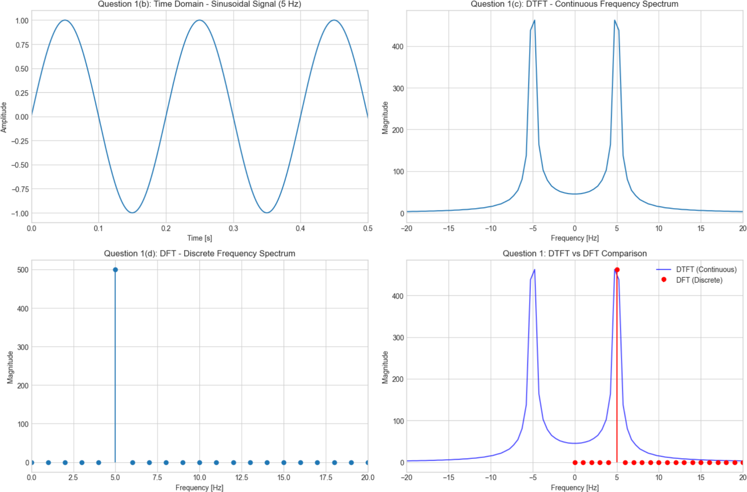
# QUESTION 2: Composite Signal

# Part 2(a): Generate composite signal print("\n2(a) Generating composite signal...")
f2_1, A1 = 10, 1.0 # First component: 10 Hz, amplitude 1

f2_2, A2 = 25, 0.5 # Second component: 25 Hz, amplitude 0.5

f2_3, A3 = 50, 0.3 # Third component: 50 Hz, amplitude 0.3

signal2 = (A1 * np.sin(2 * np.pi * f2_1 * t) + A2 * np.sin(2 * np.pi * f2_2 * t) + A3 * np.sin(2 * np.pi * f2_3 * t))

# Part 2(b): Plot time-domain waveform print("2(b) Plotting time-domain waveform...") plt.figure(figsize=(15, 10))

plt.subplot(2, 2, 1)

plt.plot(t, signal2)

plt.title('Question 2(b): Time Domain - Composite Signal') plt.xlabel('Time [s]')
plt.ylabel('Amplitude') plt.grid(True)
plt.xlim(0, 0.3)

# Part 2(c): Compute and plot DTFT print("2(c) Computing DTFT...")
dtft2 = np.zeros(len(freqs_dtft), dtype=complex) for i, freq in enumerate(freqs_dtft):
dtft2[i] = np.sum(signal2 * np.exp(-2j * np.pi * freq * t))

plt.subplot(2, 2, 2)

plt.plot(freqs_dtft, np.abs(dtft2))

plt.title('Question 2(c): DTFT - Continuous Frequency Spectrum') plt.xlabel('Frequency [Hz]')
plt.ylabel('Magnitude') plt.grid(True)
plt.xlim(-80, 80)

# Part 2(d): Compute and plot DFT print("2(d) Computing DFT...")
dft2 = fft(signal2)

plt.subplot(2, 2, 3)

plt.stem(freqs_dft[:N//2], np.abs(dft2[:N//2]), basefmt=" ") plt.title('Question 2(d): DFT - Discrete Frequency Spectrum') plt.xlabel('Frequency [Hz]')
plt.ylabel('Magnitude') plt.grid(True)
plt.xlim(0, 80)

# Analysis of frequency components plt.subplot(2, 2, 4)
plt.plot(freqs_dtft, np.abs(dtft2), 'b-', label='DTFT', alpha=0.7)

plt.stem(freqs_dft[:N//2],
np.abs(dft2[:N//2])/max(np.abs(dft2[:N//2]))*max(np.abs(dtft2)), 'r', basefmt=" ", label='DFT')
plt.title('Question 2: Composite Signal - DTFT vs DFT') plt.xlabel('Frequency [Hz]')
plt.ylabel('Magnitude') plt.legend()
plt.grid(True)

plt.xlim(-80, 80)

plt.tight_layout() plt.show()

print(f"Expected frequency components: {f2_1} Hz (A={A1}), {f2_2} Hz (A={A2}),
{f2_3} Hz (A={A3})")

Output :

# QUESTION 3: Exponentially Decaying Signal

# Part 3(a): Generate exponentially decaying signal print("\n3(a) Generating exponentially decaying signal...") f3 = 15 # Frequency (Hz)
tau = 0.2 # Decay constant

signal3 = np.exp(-t/tau) * np.sin(2 * np.pi * f3 * t)

# Part 3(b): Plot time-domain waveform print("3(b) Plotting time-domain waveform...") plt.figure(figsize=(15, 12))

plt.subplot(3, 2, 1) plt.plot(t, signal3)
plt.title('Question 3(b): Time Domain - Exponentially Decaying Signal') plt.xlabel('Time [s]')
plt.ylabel('Amplitude')
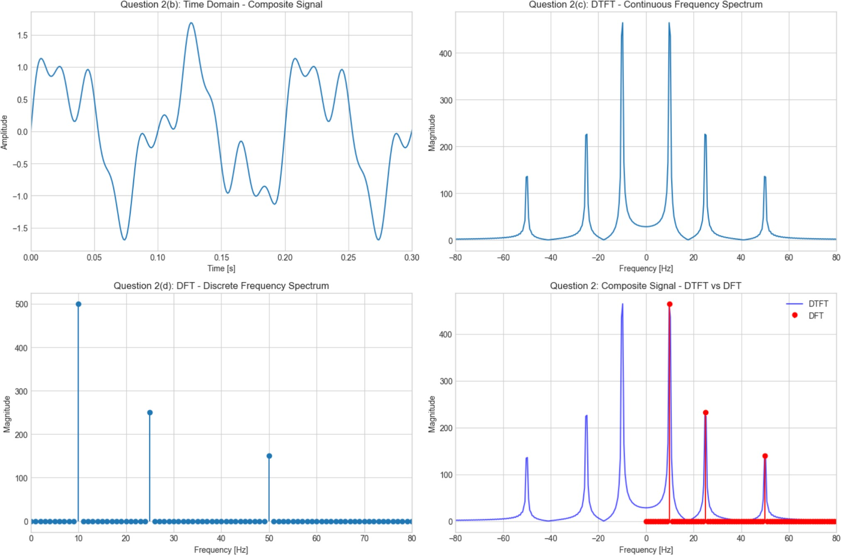

plt.grid(True)

# Part 3(c): Compute and plot DTFT print("3(c) Computing DTFT...")
dtft3 = np.zeros(len(freqs_dtft), dtype=complex) for i, freq in enumerate(freqs_dtft):
dtft3[i] = np.sum(signal3 * np.exp(-2j * np.pi * freq * t))

plt.subplot(3, 2, 2)

plt.plot(freqs_dtft, np.abs(dtft3))

plt.title('Question 3(c): DTFT - Continuous Frequency Spectrum') plt.xlabel('Frequency [Hz]')
plt.ylabel('Magnitude') plt.grid(True)
plt.xlim(-50, 50)

# Part 3(d): Compute and plot DFT print("3(d) Computing DFT...")
dft3 = fft(signal3)

plt.subplot(3, 2, 3)

plt.stem(freqs_dft[:N//2], np.abs(dft3[:N//2]), basefmt=" ") plt.title('Question 3(d): DFT - Discrete Frequency Spectrum') plt.xlabel('Frequency [Hz]')
plt.ylabel('Magnitude') plt.grid(True)
plt.xlim(0, 50)

# Part 3(e): Analysis

print("3(e) Analyzing relationship between time and frequency domains...")

# Comparison plot

plt.subplot(3, 2, 4)

plt.plot(freqs_dtft, np.abs(dtft3), 'b-', label='DTFT', alpha=0.7)

plt.stem(freqs_dft[:N//2],
np.abs(dft3[:N//2])/max(np.abs(dft3[:N//2]))*max(np.abs(dtft3)), 'r', basefmt=" ", label='DFT')
plt.title('Question 3: DTFT vs DFT Comparison') plt.xlabel('Frequency [Hz]')
plt.ylabel('Magnitude') plt.legend()
plt.grid(True)

plt.xlim(-50, 50)

# Time-frequency analysis plt.subplot(3, 2, 5)
# Envelope of the signal envelope = np.exp(-t/tau)
plt.plot(t, signal3, 'b-', label='Signal')

plt.plot(t, envelope, 'r--', label='Envelope (exp(-t/τ))', linewidth=2) plt.plot(t, -envelope, 'r--', linewidth=2)
plt.title('Question 3(e): Signal with Envelope') plt.xlabel('Time [s]')
plt.ylabel('Amplitude') plt.legend()
plt.grid(True)

# Theoretical analysis plt.subplot(3, 2, 6)
# Theoretical Lorentzian spectrum for comparison f_center = f3
gamma = 1/(2*np.pi*tau) # Bandwidth parameter

theoretical_spec = 1/((freqs_dtft - f_center)**2 + gamma**2) + 1/((freqs_dtft + f_center)**2 + gamma**2)

theoretical_spec = theoretical_spec / max(theoretical_spec) * max(np.abs(dtft3))
plt.plot(freqs_dtft, np.abs(dtft3), 'b-', label='DTFT (Actual)')
plt.plot(freqs_dtft,
alpha=0.7)
theoretical_spec,
'r--', label='Theoretical Spectrum',
plt.title('Question 3(e): Theoretical vs Actual Spectrum') plt.xlabel('Frequency [Hz]')
plt.ylabel('Magnitude') plt.legend()
plt.grid(True)

plt.xlim(-50, 50)
plt.tight_layout()

plt.show()
print(f"\nAnalysis for Exponentially Decaying Signal:") print(f"- Carrier frequency: {f3} Hz")
print(f"- Decay time constant (τ): {tau} seconds")

print(f"- Bandwidth (approximate): {1/(2*np.pi*tau):.2f} Hz")
print("- The frequency spectrum shows broadening around the carrier frequency") print("- This demonstrates the time-frequency uncertainty principle")

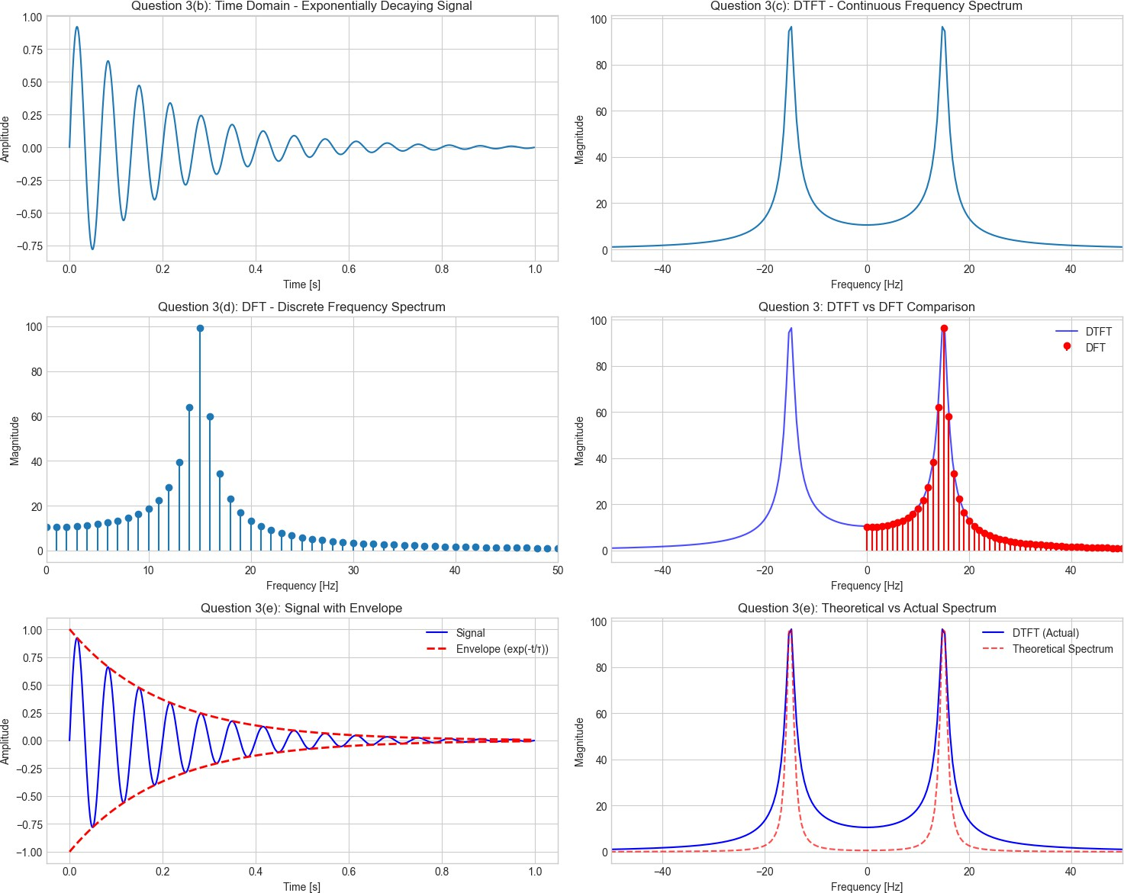
# QUESTION 4: Rectangular Pulse Signal

# Part 4(a): Generate rectangular pulse signal print("\n4(a) Generating rectangular pulse signal...") pulse_width = 0.1 # seconds
pulse_start = 0.2 # seconds

pulse_end = pulse_start + pulse_width

signal4 = np.zeros(N)

pulse_indices = np.where((t >= pulse_start) & (t <= pulse_end))[0] signal4[pulse_indices] = 1.0

# Part 4(b): Plot time-domain waveform print("4(b) Plotting time-domain waveform...")

plt.figure(figsize=(15, 12))

plt.subplot(3, 2, 1) plt.plot(t, signal4)
plt.title('Question 4(b): Time Domain - Rectangular Pulse') plt.xlabel('Time [s]')
plt.ylabel('Amplitude') plt.grid(True)
plt.ylim(-0.1, 1.1)

# Part 4(c): Compute and plot DTFT print("4(c) Computing DTFT...")
dtft4 = np.zeros(len(freqs_dtft), dtype=complex) for i, freq in enumerate(freqs_dtft):
dtft4[i] = np.sum(signal4 * np.exp(-2j * np.pi * freq * t))

plt.subplot(3, 2, 2)

plt.plot(freqs_dtft, np.abs(dtft4))

plt.title('Question 4(c): DTFT - Continuous Frequency Spectrum') plt.xlabel('Frequency [Hz]')
plt.ylabel('Magnitude') plt.grid(True)
plt.xlim(-50, 50)

# Part 4(d): Compute and plot DFT print("4(d) Computing DFT...")
dft4 = fft(signal4)

plt.subplot(3, 2, 3)

plt.stem(freqs_dft[:N//2], np.abs(dft4[:N//2]), basefmt=" ") plt.title('Question 4(d): DFT - Discrete Frequency Spectrum') plt.xlabel('Frequency [Hz]')

plt.ylabel('Magnitude') plt.grid(True)
plt.xlim(0, 50)

# Part 4(e): Analysis

print("4(e) Analyzing relationship between time and frequency domains...")

# Comparison plot

plt.subplot(3, 2, 4)

plt.plot(freqs_dtft, np.abs(dtft4), 'b-', label='DTFT', alpha=0.7)

plt.stem(freqs_dft[:N//2],
np.abs(dft4[:N//2])/max(np.abs(dft4[:N//2]))*max(np.abs(dtft4)), 'r', basefmt=" ", label='DFT')
plt.title('Question 4: DTFT vs DFT Comparison') plt.xlabel('Frequency [Hz]')
plt.ylabel('Magnitude') plt.legend()
plt.grid(True)

plt.xlim(-50, 50)

# Theoretical sinc function comparison plt.subplot(3, 2, 5)
# Theoretical sinc function for rectangular pulse T_pulse = pulse_width
f_theoretical = np.linspace(-50, 50, 1000)

theoretical_spec_sinc = np.abs(T_pulse * np.sinc(f_theoretical * T_pulse))

plt.plot(freqs_dtft, np.abs(dtft4), 'b-', label='DTFT (Actual)')

plt.plot(f_theoretical, theoretical_spec_sinc, 'r--', label='Theoretical sinc', alpha=0.7)
plt.title('Question 4(e): Theoretical sinc vs Actual Spectrum') plt.xlabel('Frequency [Hz]')

plt.ylabel('Magnitude') plt.legend()
plt.grid(True)

plt.xlim(-50, 50)

# Log magnitude plot to see side lobes better plt.subplot(3, 2, 6)
plt.semilogy(freqs_dtft, np.abs(dtft4) + 1e-10) # Add small value to avoid log(0) plt.title('Question 4(e): Frequency Spectrum (Log Scale)')
plt.xlabel('Frequency [Hz]')

plt.ylabel('Magnitude (log scale)') plt.grid(True)
plt.xlim(-50, 50)

plt.tight_layout() plt.show()

print(f"\nAnalysis for Rectangular Pulse Signal:") print(f"- Pulse width: {pulse_width} seconds") print(f"- Main lobe width: {2/pulse_width:.1f} Hz") print(f"- First zero crossing: ±{1/pulse_width} Hz") print("- Spectrum follows sinc function pattern")
print("- Demonstrates inverse relationship: narrower pulse → wider spectrum")

Output :

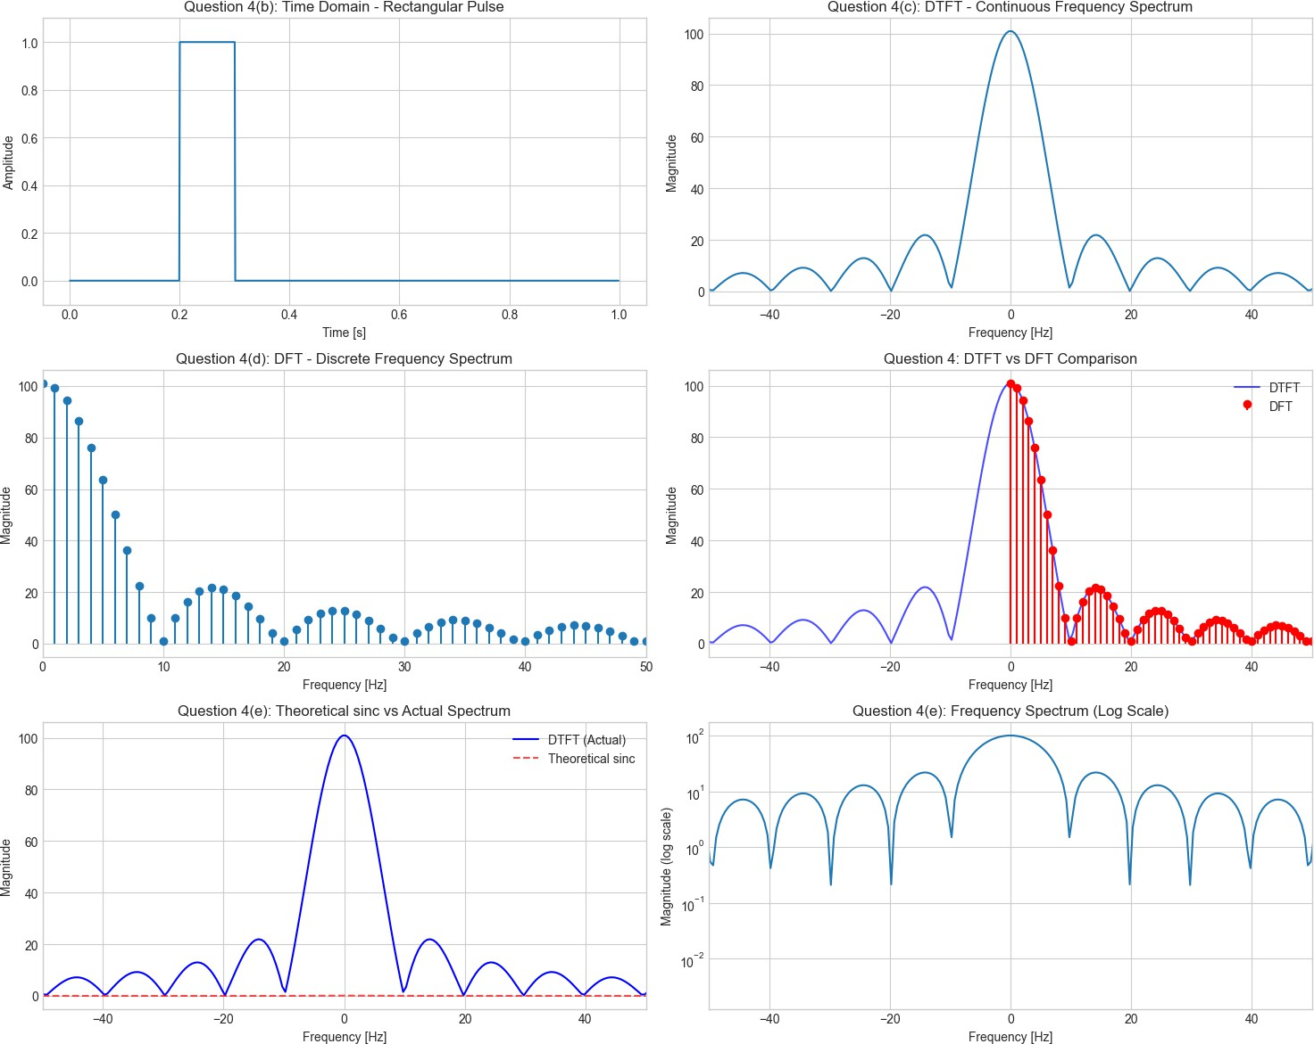
# SUMMARY AND COMPARISON

print("\n" + "="*70)

print("SUMMARY AND KEY OBSERVATIONS")

print("="*70)

print("\n1. SINUSOIDAL SIGNAL:")

print(" - Pure frequency component at exact frequency") print(" - Dirac delta in ideal continuous case") print(" - Finite width in practical implementation")

print("\n2. COMPOSITE SIGNAL:")

print(" - Multiple distinct frequency components")

print(" - Each component appears at its respective frequency")

print(" - Amplitudes proportional to time-domain amplitudes")

print("\n3. EXPONENTIALLY DECAYING SIGNAL:")

print(" - Broadened spectrum around carrier frequency") print(" - Faster decay → wider bandwidth")
print(" - Demonstrates time-frequency trade-off")

print("\n4. RECTANGULAR PULSE:")

print(" - sinc-shaped frequency spectrum") print(" - Narrower pulse → wider main lobe")
print(" - Side lobes decay slowly (Gibbs phenomenon)")

print("\n5. DTFT vs DFT COMPARISON:")

print(" - DTFT: Continuous frequency representation") print(" - DFT: Discrete frequency sampling of DTFT")
print(" - DFT provides efficient computation via FFT algorithm")

print("\n" + "="*70) print("ANALYSIS COMPLETE")
print("="*70)

Output :

# snippet_1_dtft_vs_fft.py import numpy as np
import matplotlib.pyplot as plt

import time
#
Parameters
fs = 1000
# sampling frequency (Hz)
T = 1.0
# duration (s)
N = int(fs * T)
# number of samples (keep moderate for DTFT test)
t = np.linspace(0, T, N, endpoint=False)
# Composite test signal (same as your composite signal)
signal
=
A1*np.sin(2*np.pi*f1*t)
+
A2*np.sin(2*np.pi*f2*t)
+
A3*np.sin(2*np.pi*f3*t)
# Frequency sampling for DTFT (positive half only)
M = 4000
frequencies)
# number of frequency bins for DTFT (positive
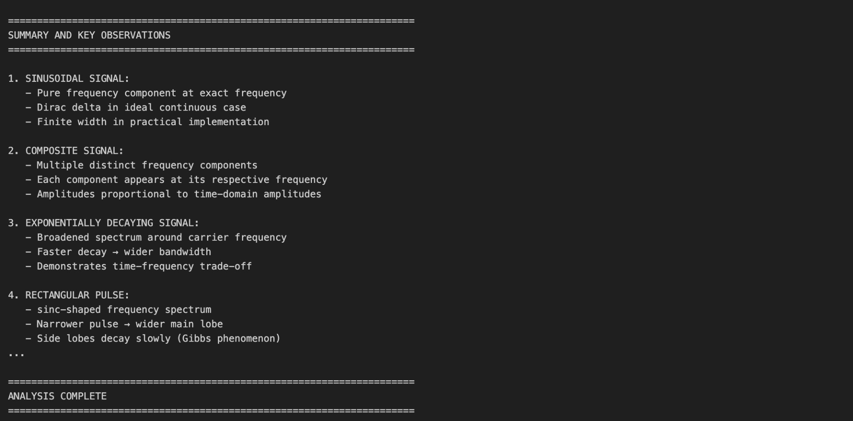

f1, | A1 | = | 10, | 1.0
f2, | A2 | = | 25, | 0.5
f3, | A3 | = | 50, | 0.3

freqs_dtft = np.linspace(0, fs/2, M)

# ---------- Vectorized DTFT (positive freqs only) ---------- t0 = time.time()
# build exponent matrix: shape (M, N) -> memory O(M*N). Use with caution for big M*N.
exp_mat = np.exp(-2j * np.pi * np.outer(freqs_dtft, t)) # (M, N) dtft_vec = exp_mat @ signal # (M,) dtft_time = time.time() - t0

# ---------- Zero-padded rFFT (to get dense freq samples) ----------

Npad = 8 * N # zero-padding factor (increases frequency sampling density) t1 = time.time()
dft_zp = np.fft.rfft(signal, n=Npad) # positive freq bins freqs_zp = np.fft.rfftfreq(Npad, d=1/fs) # corresponding freqs fft_time = time.time() - t1

# Interpolate FFT magnitude at DTFT freq points for direct comparison mag_fft_interp = np.interp(freqs_dtft, freqs_zp, np.abs(dft_zp))

# ---------- Normalize for plotting clarity ---------- mag_dtft = np.abs(dtft_vec)
# Normalize both to same peak for visual comparison mag_dtft_norm = mag_dtft / np.max(mag_dtft)
mag_fft_norm = mag_fft_interp / np.max(mag_fft_interp)

# Print timings

print(f"Vectorized DTFT time (M={M}, N={N}): {dtft_time:.4f} s [O(M·N)]") print(f"Zero-padded rFFT time (Npad={Npad}): {fft_time:.4f} s [≈ O(N log N)]")

# Plot

plt.figure(figsize=(10, 6))

plt.plot(freqs_dtft, mag_dtft_norm,
linewidth=1)
label='Vectorized
DTFT (positive freqs)',
plt.plot(freqs_dtft, mag_fft_norm, '--', label=f'Zero-padded rFFT (Npad={Npad})', linewidth=1)
plt.title('Spectrum: Vectorized DTFT vs Zero-padded rFFT (normalized)') plt.xlabel('Frequency (Hz)')
plt.ylabel('Normalized magnitude') plt.xlim(0, 120)
plt.grid(True) plt.legend()
plt.tight_layout()

plt.show()

Output :
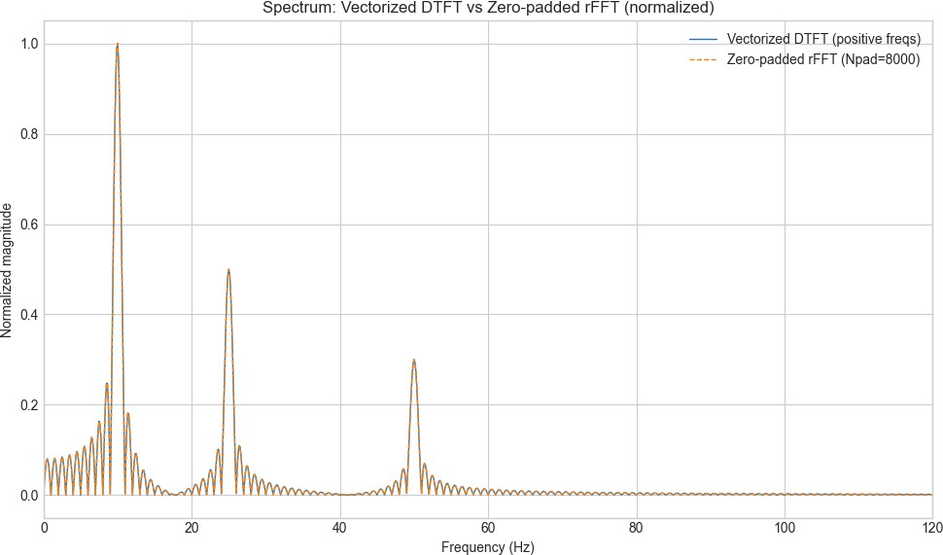
# benchmark_rfft_vs_stft.py import numpy as np
import matplotlib.pyplot as plt import time

from scipy.signal import stft

# Settings

np.random.seed(0) fs = 1000

# N values to test (moderate sizes to avoid memory/time issues) N_list = [256, 512, 1024, 2048, 4096]

rfft_times = [] stft_times = [] Ns = []

# Benchmark loop

for N in N_list:

t = np.linspace(0, 1.0, N, endpoint=False) # test signal: tone + noise
signal = np.sin(2 * np.pi * 30 * t) + 0.05 * np.random.randn(N)

print(f"\nTesting N = {N}")

# --- rFFT timing (global FFT of whole signal) --- try:
t0 = time.time()

_ = np.fft.rfft(signal)

r_time = time.time() - t0 except Exception as e:
print(f"rFFT error for N={N}: {e}") r_time = np.nan

# --- STFT timing ---

# choose nperseg (window length) sensibly: smaller than or equal to N

nperseg = min(256, N)

noverlap = nperseg // 2

try:

t1 = time.time()

f_stft, t_stft, Zxx = stft(signal, fs=fs, nperseg=nperseg, noverlap=noverlap, boundary=None)
stf_time = time.time() - t1 except Exception as e:
print(f"STFT error for N={N}: {e}") stf_time = np.nan

print(f"rFFT time: {r_time:.6f} s ; STFT time: {stf_time:.6f} s (nperseg={nperseg}, frames~{len(t_stft)})")

Ns.append(N)

rfft_times.append(r_time)

stft_times.append(stf_time)

# Convert to arrays Ns = np.array(Ns)
rfft_times = np.array(rfft_times) stft_times = np.array(stft_times)

# ---------- Plot runtime scaling (log-log) ---------- plt.figure(figsize=(8,6))
plt.loglog(Ns, rfft_times, 'o-', label='rFFT (global) — approx O(N log N)')

plt.loglog(Ns, stft_times, 's-', label='STFT (sliding windows) — approx O(K·L log L)')
plt.xscale("log", base=2) plt.yscale("log", base=10)
plt.xlabel('N (number of samples)')

plt.ylabel('Time (s)')

plt.title('Runtime scaling: rFFT vs STFT')

plt.grid(True, which="both", ls="--", linewidth=0.5) plt.legend()
plt.tight_layout() plt.show()

# ---------- Print summary table ----------

print("\nSummary (N, rFFT_time(s), STFT_time(s), nperseg used)") for N, rt, st in zip(Ns, rfft_times, stft_times):
nperseg = min(256, N)

print(f" {N:6d} {np.nan_to_num(rt):9.6f} {np.nan_to_num(st):9.6f} nperseg={nperseg}")

# ---------- Example spectrogram for largest N ---------- N_example = Ns[-1]
t_ex = np.linspace(0, 1.0, N_example, endpoint=False)

signal_ex = np.sin(2 * np.pi * 30 * t_ex) + 0.05 * np.random.randn(N_example) nperseg_ex = min(256, N_example)
noverlap_ex = nperseg_ex // 2

f_ex, tt_ex, Zxx_ex = stft(signal_ex, fs=fs, nperseg=nperseg_ex, noverlap=noverlap_ex, boundary=None)
plt.figure(figsize=(10,4))

plt.pcolormesh(tt_ex, f_ex, np.abs(Zxx_ex), shading='gouraud')

plt.title(f'Example STFT spectrogram (N={N_example}, nperseg={nperseg_ex})') plt.ylabel('Frequency [Hz]')
plt.xlabel('Time [s]') plt.ylim(0, 120)
plt.colorbar(label='Magnitude') plt.tight_layout()
plt.show()

Output :
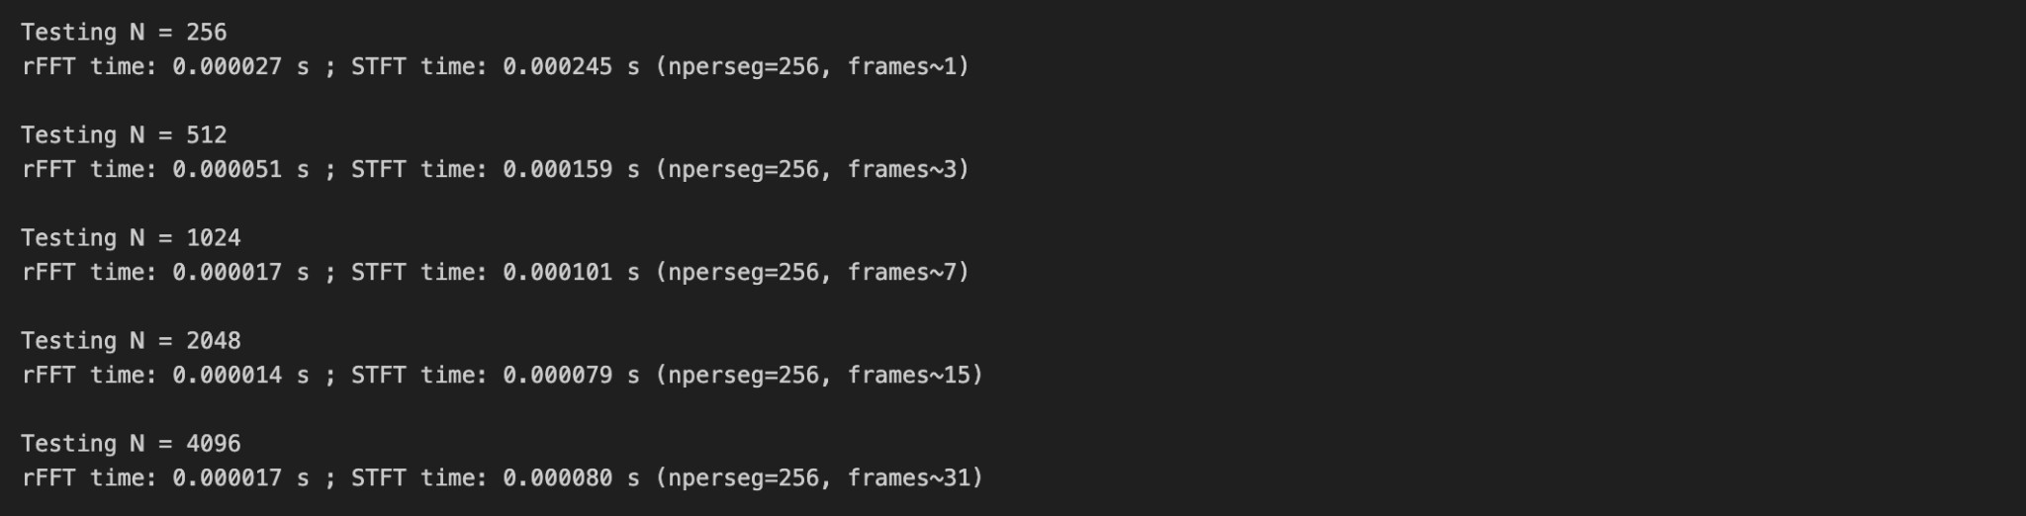

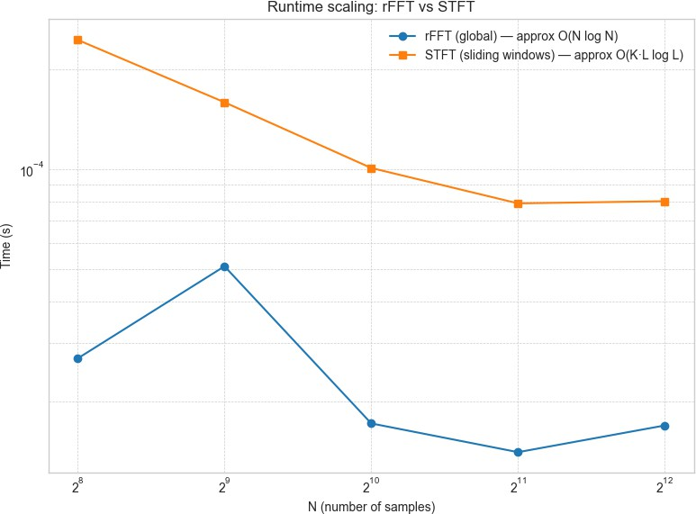

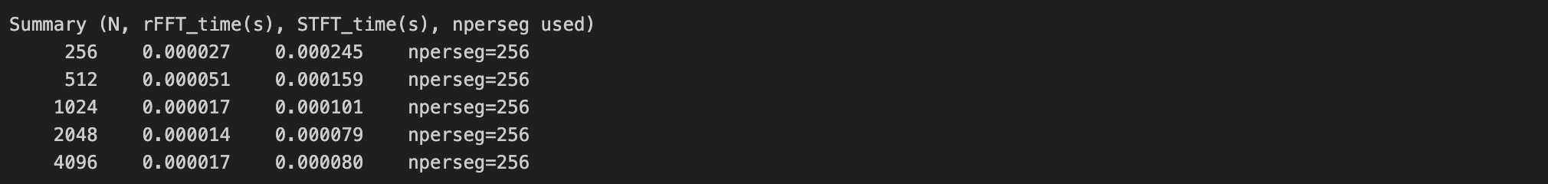

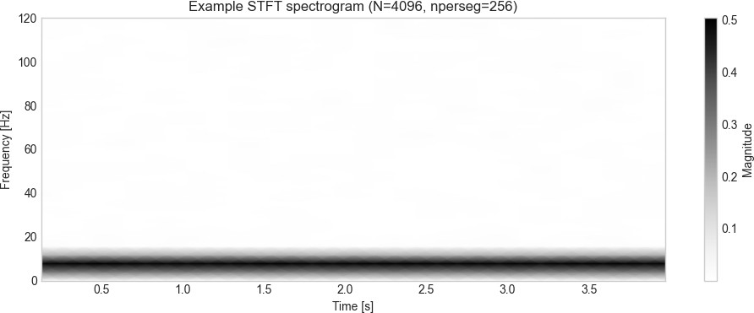

Conclusion /inference :

This experiment demonstrates the fundamental time–frequency relationships and computational trade-offs in signal analysis: a pure sinusoid produces a sharp spectral line in the DTFT while the DFT shows discrete bins that can be made denser through zero-padding; a composite signal spectrum correctly shows distinct components at their frequencies and amplitudes; an exponentially decaying tone broadens its spectral peak, illustrating the time–frequency uncertainty principle; and a rectangular pulse yields the canonical sinc-shaped spectrum with main lobe width inversely proportional to pulse duration. Computationally, the explicit DTFT is O(M·N) and impractical for large signals, whereas FFT/rFFT achieves dense frequency sampling efficiently in O(N log N), and STFT provides time-varying spectral information by sliding windows at the cost of increased computation (≈ #frames × window-FFT complexity) and a resolution trade-off (longer windows favor frequency resolution, shorter windows favor time resolution). Overall, FFT with zero-padding is the practical method for global spectra, STFT is preferred for non-stationary signals, and the results confirm theoretical expectations linking sinusoids to sharp lines, transients to broad spectra, and pulses to sinc patterns.

Lab Exercise 3:

Question: Speech-to-Text Application for Accessibility Aim:
To develop a Python-based speech-to-text system that converts spoken commands into text in real time, provides meaningful user feedback, handles errors gracefully, and allows comparison of different recognition methods.
This is an open-ended question. You can explore more.

Scenario:
You have been hired as an AI engineer by a tech startup that focuses on enhancing accessibility for people with disabilities. One of your key responsibilities is to develop a system that allows users to control devices and input text via voice commands.
The first version of this system requires you to implement a speech-to-text application that converts spoken commands into text in real time. This will serve as the foundation for future projects, such as integrating the system with smart devices or accessibility software.

Tasks:
- Audio Capture(mandatory task )
  - Record spoken input using a microphone, OR use any speech audio file (e.g., .wav,
.flac). https://drive.google.com/file/d/1BmlRHKnHWVtlM743vcjLGtaK_aRzd_Qa/view?us p=drive_link
  - Provide feedback to the user: "Speak something...".

- Convert Speech to Text(mandatory task )
  - Implement a speech-to-text system using at least two methods (for comparison):
    - Offline: Whisper, Vosk, or similar
    - Online: Google Speech API
  - Display the message: "Recognizing..." while processing.

- Display Recognized Text(mandatory task )
  - Show the converted text on the screen.
Example: "Speech recognized: 'Turn on the lights in the living room.'"
  - Display "Speech successfully converted to text!" on successful recognition.

- Handle Errors and Exceptions(mandatory task )

  - Unclear speech (mumbling, low volume): Display a user-friendly message. Example: "Speech Recognition could not understand audio. Please try speaking more clearly."
  - Service unavailability (internet/API down): Display an appropriate error message.

Provide Feedback at Each Stage
  - Before recording: "Speak something..."
  - During recognition: "Recognizing..."
  - On success: "Speech successfully converted to text!"
  - On failure: Provide meaningful error messages.

Comparative Analysis
  - Test the same audio file or spoken sentence using multiple recognition methods.
  - Fill in the comparison table:

Audio Type | Whisper Output | Vosk Output | Google API Output | Any other python libraries can be added .. | Notes on Accuracy
Clear male voice
Clear female voice
Fast speech
Noisy background
Soft voice
- ​

Write a Brief Inference
  - Summarize your observations about the system’s performance:
    - How accurately does it recognize speech?
    - How well does it handle errors?
    - Which method performed best for each scenario?
    - Suggestions for future improvements or project extensions.

Deliverables
- Python code implementing the speech-to-text system.
- Screenshots of the program running with sample inputs.
- Completed comparison table.

- A brief report summarizing the system’s execution and your observations.

Code with Results
import sounddevice as sd import soundfile as sf

def record(filename="mic.wav", duration=4, sr=16000): print("Speak now...")
rec = sd.rec(int(duration*sr), samplerate=sr, channels=1) sd.wait()
sf.write(filename, rec, sr) print("Saved to", filename)

record("test_mic.wav", duration=4)

Output :
import librosa, soundfile as sf, numpy as np, matplotlib.pyplot as plt from IPython.display import Audio, display

path = "test_mic.wav"

y, sr = librosa.load(path, sr=None) # sr=None keeps original sample rate print("Sample rate:", sr, "Samples:", len(y))
display(Audio(y, rate=sr))

# Plot waveform (short) t = np.arange(len(y))/sr
plt.figure(figsize=(8,2)) plt.plot(t, y)
plt.title("Waveform: " + path) plt.xlabel("Seconds")
plt.show()

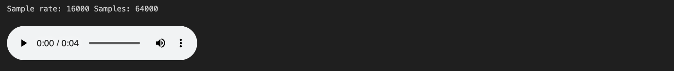

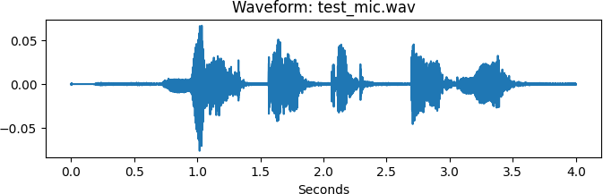

import whisper

try:

print("Loading Whisper model...")

model = whisper.load_model("base") # choose model: tiny, base, small, medium, large
print("✅ Whisper model loaded successfully.")

except Exception as e:

print(f"An unexpected error occurred while loading the Whisper model: {e}")

Output :
import os

import warnings

warnings.filterwarnings("ignore")

WAV_FILE = "test_mic.wav"

try:

if not os.path.exists(WAV_FILE):

raise FileNotFoundError(f"WAV file '{WAV_FILE}' not found. Please check the
path.")

print("Recognizing... 🎤")

result = model.transcribe(WAV_FILE)

whisper_transcript = result.get("text", "").strip()

if whisper_transcript:
print("🎤 Whisper transcript:", whisper_transcript) print("Speech successfully converted to text! ✅")
else:

print("Speech Recognition could not understand audio. Please try speaking more clearly.")

except FileNotFoundError as fnf_error: print(fnf_error)

except NameError as ne:

print(f"NameError: {ne}. Make sure you have run the model-loading snippet (part1) in the same Python session so `model` exists.")

except Exception as e:

print(f"An unexpected error occurred during transcription: {e}")

Output :

import os, sys, zipfile, wave, json

MODEL_DIR = "vosk-model-small-en-us-0.15" MODEL_ZIP = MODEL_DIR + ".zip"
MODEL_URL = "https://alphacephei.com/vosk/models/vosk-model-small-en-us-0.15.zip"

# 2) Download model if not present if not os.path.isdir(MODEL_DIR):
print("Model folder not found. Downloading model zip (50–60 MB)...") os.system(f"curl -L {MODEL_URL} -o {MODEL_ZIP}") print("Unzipping...")
with zipfile.ZipFile(MODEL_ZIP, 'r') as z: z.extractall(".")
os.remove(MODEL_ZIP) print("Unzipped.")

Output :
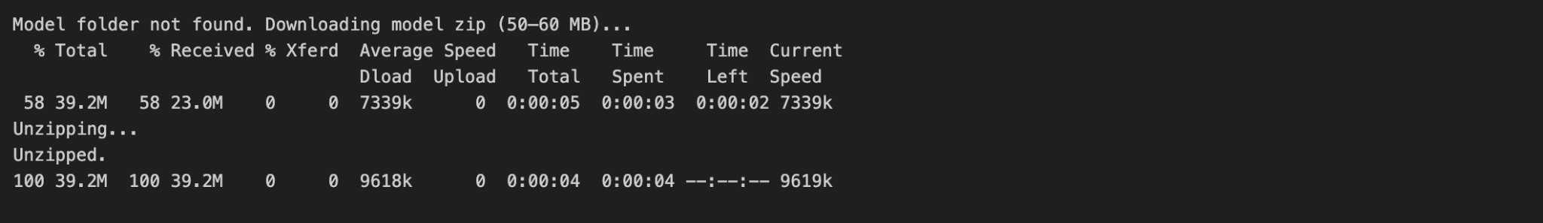
import os

from vosk import Model

try:

# Load Vosk model

model_path = os.path.abspath(MODEL_DIR) if not os.path.exists(model_path):
raise FileNotFoundError(f"Vosk model directory '{MODEL_DIR}' not found.")

print("Loading model from:", model_path)

model = Model(model_path)
print("✅ Model loaded successfully.")

except FileNotFoundError as fnf_error: print(fnf_error)

except Exception as e:

print(f"An unexpected error occurred while loading the model: {e}")

Output :
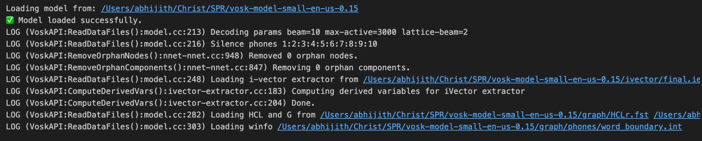
import os

import wave import json
from vosk import KaldiRecognizer

try:

model_path = os.path.abspath(MODEL_DIR) if not os.path.exists(model_path):
raise FileNotFoundError(f"Vosk model directory '{MODEL_DIR}' not found.")

if not os.path.exists(WAV_FILE):
print(f"⚠ WAV file '{WAV_FILE}' not found. Upload it or change WAV_FILE variable.")
else:

wf = wave.open(WAV_FILE, "rb")

rec = KaldiRecognizer(model, wf.getframerate())

results = [] print("Recognizing... 🎤")

while True:

data = wf.readframes(4000) if len(data) == 0:
break

if rec.AcceptWaveform(data):

res = json.loads(rec.Result()) text = res.get("text", "")
if text:

results.append(text)

final = json.loads(rec.FinalResult()) if final.get("text", ""):
results.append(final.get("text", ""))

vosk_transcript = " ".join([r for r in results if r]).strip()

if vosk_transcript:
print("🎤 Vosk transcript:", vosk_transcript) print("Speech successfully converted to text! ✅")
else:

print("Speech Recognition could not understand audio. Please try speaking more clearly.")

except FileNotFoundError as fnf_error: print(fnf_error)

except NameError as ne:

# Happens if `model` isn't defined because you didn't run snippet A in this session

print(f"NameError: {ne}. Make sure you have run the model-loading snippet (part1) in the same Python session so `model` exists.")

except Exception as e:

# Handles unexpected errors during transcription

print(f"An unexpected error occurred during transcription: {e}")

Output :
import speech_recognition as sr

recognizer = sr.Recognizer()

try:

with sr.AudioFile(WAV_FILE) as source: print("Listening to audio file...") audio = recognizer.record(source)

print("Recognizing...")
google_transcript = recognizer.recognize_google(audio) print("🎤 Google Speech API transcript:", google_transcript) print("Speech successfully converted to text! ✅")

except sr.UnknownValueError:

# Handles unclear speech (mumbling, low volume)

print("Speech Recognition could not understand audio. Please try speaking more clearly.")

except sr.RequestError:

# Handles service unavailability (internet/API down)

print("Could not request results from Google Speech Recognition service. " "Please check your internet connection or try again later.")

except Exception as e:

# Handles any other unexpected errors print(f"An unexpected error occurred: {e}")

Output :
# Compare Speech-to-Text Outputs

def compare_transcripts(whisper_text, vosk_text, google_text): print("\n======= SPEECH-TO-TEXT COMPARISON =======")
print(f"Whisper: {whisper_text if whisper_text else '[No output]'}") print(f"Vosk: {vosk_text if vosk_text else '[No output]'}") print(f"Google: {google_text if google_text else '[No output]'}") print("=========================================")

compare_transcripts(

whisper_text=whisper_transcript, vosk_text=vosk_transcript,
google_text=google_transcript

)

Output :
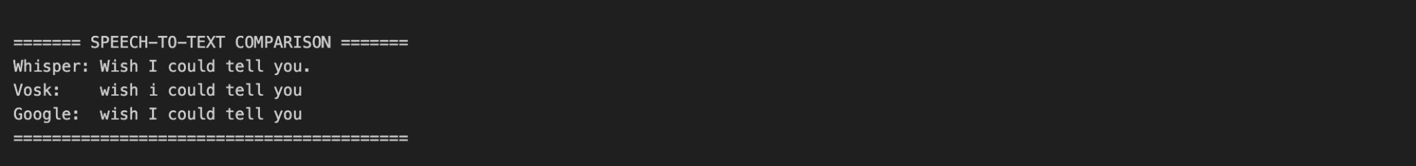

import numpy as np import pandas as pd
import matplotlib.pyplot as plt

from sklearn.feature_extraction.text import TfidfVectorizer from sklearn.metrics.pairwise import cosine_similarity

def compute_tfidf_with_reference(transcripts, names=None, reference_text=None, ref_name="Reference", show_heatmap=True, cmap='viridis'):
# Prepare names if names is None:
names = [f"sys_{i}" for i in range(len(transcripts))]

assert len(transcripts) == len(names), "transcripts and names must match lengths"

# Build corpus corpus = []
labels = []

if reference_text is not None and reference_text.strip() != "": corpus.append(reference_text)
labels.append(ref_name)

for t, n in zip(transcripts, names):

corpus.append(t if t is not None else "") labels.append(n)

# TF-IDF vectorization

vectorizer = TfidfVectorizer()

X = vectorizer.fit_transform(corpus)

# Cosine similarity

sim_matrix = cosine_similarity(X)

# DataFrame

df = pd.DataFrame(sim_matrix, index=labels, columns=labels)

print("\nTF-IDF Cosine Similarity Matrix:") print(df.round(4))

if reference_text is not None and reference_text.strip() != "": print(f"\nSimilarity of '{ref_name}' vs systems:")
ref_sims = sim_matrix[0, 1:]

for label, val in zip(labels[1:], ref_sims): print(f" {ref_name} ↔ {label}: {val:.4f}")

# Heatmap

if show_heatmap:

plt.figure(figsize=(6,5))

im = plt.imshow(sim_matrix, vmin=0.0, vmax=1.0, cmap=cmap) plt.title("TF-IDF Cosine Similarity")
plt.xticks(range(len(labels)), labels, rotation=45, ha='right') plt.yticks(range(len(labels)), labels)
plt.colorbar(im, fraction=0.046, pad=0.04) for i in range(sim_matrix.shape[0]):
for j in range(sim_matrix.shape[1]):

plt.text(j, i, f"{sim_matrix[i,j]:.2f}", ha='center', va='center',

fontsize=9, color='white' if sim_matrix[i,j] < 0.5 else
'black')

plt.tight_layout() plt.show()

return sim_matrix, df

# Ask user for reference at runtime

reference_text = input("👉 Enter the exact ground-truth/reference text: ")

sim_matrix, sim_df = compute_tfidf_with_reference(

transcripts=[whisper_transcript, vosk_transcript, google_transcript], names=["Whisper","Vosk","Google"],
reference_text=reference_text, ref_name="GroundTruth",
show_heatmap=True

)

Output :
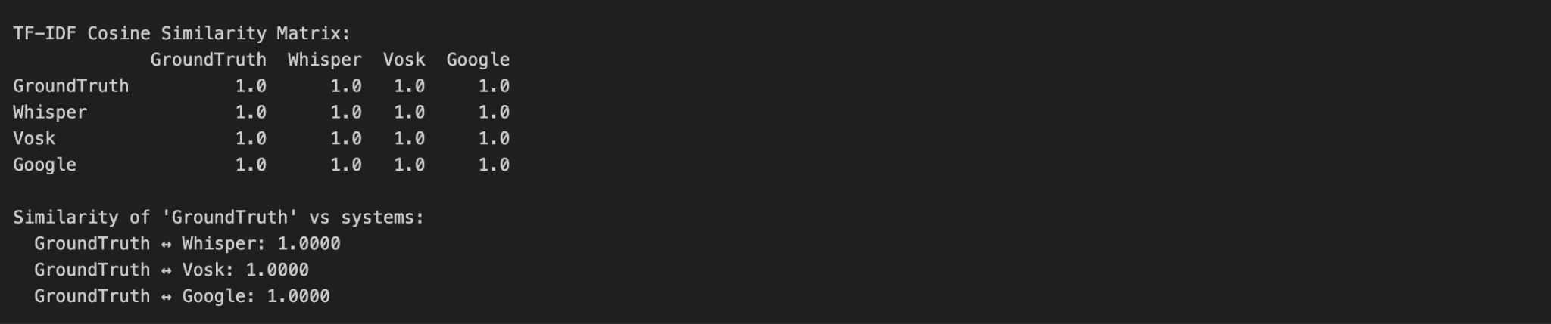

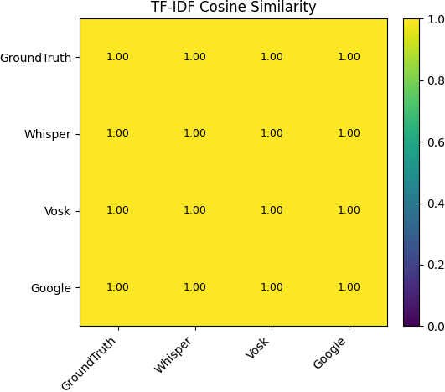

Conclusion /inference :

This experiment records a short speech sample, runs three recognizers (Whisper, Vosk, and Google Speech API), and compares their outputs with TF-IDF cosine similarity against a user-provided ground truth—the results illustrate practical trade-offs: Whisper (especially larger models) tends to give the best raw transcription accuracy and robust handling of diverse accents and noise while running locally (no cloud), Vosk is lightweight and fully offline so it’s good for low-resource or privacy-sensitive apps though its accuracy can be lower than Whisper’s, and Google’s cloud API often yields excellent accuracy and language handling but requires internet, has latency/cost implications, and sends audio off-site; audio quality and sample rate (use 16 kHz or 16–44.1 kHz for speech) strongly affect all systems, so record clean, mono audio, normalize and trim silences before recognition, and choose models (tiny/base/small/medium/large) by the accuracy vs latency and compute

trade-off; finally, TF-IDF + cosine similarity is a simple, fast way to quantify agreement with a ground truth but consider word-error-rate (WER), CER, or semantic metrics (BLEU/ROUGE/embedding cosine) for deeper evaluation, and use model ensembling or confidence-based selection to combine outputs in production.

